NOTICE OF DETERMINATION OF A DEVELOPMENT APPLICATION
Application number | 893/2025/JPZ  PAN-492737
Applicant | Landcom  Level 14 60 Station St  PARRAMATTA NSW 2150
Description of development | Subdivision to create three development lots and two open space lots including tree removal, earthworks and roads
Property | 26-28 Guragura Street, KELLYVILLE NSW 2155, Lot 1406 DP 1249937 Old Windsor Road, KELLYVILLE NSW 2155  Lot 171 DP 1252052, Lot 1406 DP 1249937, Lot 1407 DP 1249937, Lot 1408 DP 1249937
Determination | Approved  Consent Authority - <The Hills Shire Council> / <The Hills Shire Council – Development Assessment Unit> <The Hills Local Planning Panel> / <Sydney Central City Planning Panel>
Date of determination
Date from which the consent operates | <DELETE IF THIS IS A DEFERRED COMMENCEMENT CONSENT>  <INSERT DATE>
Date on which the consent lapses | <DELETE AS REQUIRED>  <INSERT DATE>
Approval bodies that have given general terms of approval | <DELETE AS REQUIRED>
Court Case name  LEC Number | <DELETE AS REQUIRED>  <INSERT COURT CASE NAME AND LEC NUMBER>
Building Code of Australia building classification | <DELETE AS REQUIRED>  < INCLUDE BUILDING CLASSIFICATION IF DEVELOPMENT INVOLVES A BUILDING BUT DOES NOT REQUIRE A CONSTRUCTION CERTIFICATE AS PER SECTION 88(1)(G) OF THE EP&A REGULATION >
Independent Planning Commission public hearing | <DELETE AS REQUIRED>  <INSERT DATE OF PUBLIC HEARING IF ONE WAS CONDUCTED>
Under section 4.18(1) of the EP&A Act, notice is given that the above development application has been determined by the granting of consent using the power in section 4.16(1)(a) of the EP&A Act, subject to the conditions specified in this notice.

Terms and Reasons for Conditions
Under section 88(1)(c) of the EP&A Regulation, the consent authority must provide the terms of all conditions and reasons for imposing the conditions other than the conditions prescribed under section 4.17(11) of the EP&A Act. The terms of the conditions and reasons are set out below.

CROWN DEVELOPMENT
GENERAL CONDITIONS

1. | Approved Plans and Supporting Documentation
1. | The development must be carried out in accordance with the following approved plans and documents, except where the conditions of this consent expressly require otherwise.  In the event of any inconsistency between the approved plans and documents, the approved plans prevail. In the event of any inconsistency with the approved plans and a condition of this consent, the condition prevails.
  Approved plans
  Plan number | Plan title | Drawn by | Date of plan
  AU006704_DP02 Sheet 1 | Plan of Subdivision | Mr K B Pritchard | 16 October 2024
  AU006704_DP02 Sheet 2 | Plan of Subdivision | Mr K B Pritchard | 16 October 2024
  AU006704_DP02 Sheet 3 | Plan of Subdivision | Mr K B Pritchard | 16 October 2024
  AU006704_DP02 Sheet 4 | Plan of Subdivision | Mr K B Pritchard | 16 October 2024
  304001090-200-C6005 Rev ‘M’ | Tree Removal Plan – Sheet 1 | Stantec | 17 April 2026
  304001090-200-C6006 Rev ‘M’ | Tree Removal Plan – Sheet 2 | Stantec | 17 April 2026
  304001090-200-C6007 Rev ‘M’ | Tree Removal Plan – Sheet 3 | Stantec | 17 April 2026
  304001090-200-C6008 Rev ‘M’ | Tree Removal Plan – Sheet 4 | Stantec | 17 April 2026
  304001090-200-C6009 Rev ‘M’ | Tree Removal Plan – Sheet 5 | Stantec | 17 April 2026
  LD-S2-KV-MP100 Rev ‘1’ | Overall Masterplan | Land and Form | 24 April 2026
  LD-S2-KV-DA000 Rev ‘6’ | Cover Sheet & Design Statement | Land and Form | 22 April 2026
  LD-S2-KV-DA001 Rev ‘6’ | Streetscape Planting Schedule & Legends | Land and Form | 22 April 2026
  LD-S2-KV-DA010 Rev ‘6’ | Tree Management Plan | Land and Form | 22 April 2026
  LD-S2-KV-DA100 Rev ‘6’ | Streetscapes Masterplan | Land and Form | 22 April 2026
  LD-S2-KV-DA101 Rev ‘6’ | Streetscapes Detail Plan 1 | Land and Form | 22 April 2026
  LD-S2-KV-DA102 Rev ‘6’ | Streetscapes Detail Plan 2 | Land and Form | 22 April 2026
  LD-S2-KV-DA103 Rev ‘6’ | Streetscapes Detail Plan 3 | Land and Form | 22 April 2026
  LD-S2-KV-DA104 Rev ‘6’ | Streetscapes Detail Plan 4 | Land and Form | 22 April 2026
  LD-S2-KV-DA105 Rev ‘6’ | Streetscapes Detail Plan 5 | Land and Form | 22 April 2026
  LD-S2-KV-DA106 Rev ‘6’ | Streetscapes Detail Plan 6 | Land and Form | 22 April 2026
  LD-S2-KV-DA201 Rev ‘6’ | Streetscapes Planting Plan 1 | Land and Form | 22 April 2026
  LD-S2-KV-DA202 Rev ‘6’ | Streetscapes Planting Plan 2 | Land and Form | 22 April 2026
  LD-S2-KV-DA203 Rev ‘6’ | Streetscapes Planting Plan 3 | Land and Form | 22 April 2026
  LD-S2-KV-DA204 Rev ‘6’ | Streetscapes Planting Plan 4 | Land and Form | 22 April 2026
  LD-S2-KV-DA205 Rev ‘6’ | Streetscapes Planting Plan 5 | Land and Form | 22 April 2026
  LD-S2-KV-DA206 Rev ‘6’ | Streetscapes Planting Plan 6 | Land and Form | 22 April 2026
  LD-S2-KV-DA400 Rev ‘6’ | Streetscapes Sections 01 | Land and Form | 22 April 2026
  LD-S2-KV-DA401 Rev ‘6’ | Streetscapes Sections 02 | Land and Form | 22 April 2026
   |  |  | 22 April 2026
  LD-S2-KV-DA402 Rev ‘6’ | Streetscapes Sections 03 | Land and Form | 22 April 2026
  LD-S2-KV-DA403 Rev ‘6’ | Streetscapes Sections 04 | Land and Form | 22 April 2026
  LD-S2-KV-DA404 Rev ‘3’ | Streetscapes Sections 05 | Land and Form | 22 April 2026
  Approved documents
  Document title | Reference | Prepared by | Date of document
  Biodiversity Development Assessment Report – Kellyville Station Precinct | 40523 Rev ‘02’ | Biosis | 4 May 2026
  Detailed Site Investigation – Kellyville Station Precinct | 304501564 Rev ‘A’ | Stantec | 2 October 2024
  Detailed Site Investigation Addendum – Response to Requirement for Remedial Action Plan | 304501564 Rev ‘C’ | Stantec | 15 May 2025
  Kellyville Station Precinct (Stages 2, 3 & 4) Flood Impact and Risk Assessment | Rev ‘3’ | Stantec | 17 April 2026
  Road Safety Audit – Kellyville Stage 2 | BTE-240035 Rev ‘3’ | BTE Consulting | 3 June 2025
  Kellyville Station Precinct – Aboriginal Heritage Impact Statement | 2325 Rev ‘1.0’ | Kelleher Nightingale Consulting | 1 August 2024
  Arboricultural Impact Assessment – Kellyville Station Precinct – Stages 2 & 3 | G224 Rev ‘C’ | Creative Planning Solutions | 1 May 2025
1. | Condition reason: To ensure all parties are aware of the approved plans and supporting documentation that applies to the development.

2. | Planning Agreement
2. | The obligations under Voluntary Planning Agreement No. 1/2025/VPA (as amended) between The Hills Shire Council, Sydney Metro and Planning Ministerial Corporation dated 29 September 2025 (the ‘Planning Agreement’) must be satisfied in accordance with the terms of the Planning Agreement, including, but not limited to, the registration of the Planning Agreement on the title of the development lots (superlots) and the payment of monetary contributions, dedication of land and completion of works as identified in Schedule 3 of the Planning Agreement.
2. | Condition reason: To contribute towards public infrastructure for the area.
3. | State Significant Development Consent – Concept Development Application
3. | The requirements and conditions of State Significant Development Consent No. SSD-10343 (as amended) for the Kellyville Station Precinct must be complied with throughout all stages of the development.
3. | Condition reason: To ensure the development is consistent with the Concept State Significant Development Application approval issued for the Kellyville Station Precinct.
4. | Crown Development – Crown Subdivision Works Certification
4. | Before any subdivision or engineering works are carried out, certification of the Crown subdivision works must be obtained and submitted for Council’s records. The plans and accompanying information submitted for certification must comply with the conditions of this consent.
4. | Condition reason: To ensure the Applicant is aware of Crown development requirements.
5. | Subdivision Certificate Preliminary Review
5. | Before the submission of a Subdivision Certificate application, a draft copy of the Final Plan, Administration Sheet and Section 88B Instrument (where included) must be submitted to Council in order to establish that all conditions have been complied with.
5. | Condition reason: To ensure that all conditions have been complied with.
6. | Process for Council Endorsement of Legal Documentation
6. | Where an encumbrance on the title of the property is required to be released or amended and Council is listed as the benefiting authority, the relevant release or amendment documentation must be submitted to Council along with payment of the applicable fee as per Council’s Schedule of Fees and Charges. Sufficient time should be allowed for the preparation of a report and the execution of the documents by Council.
6. | Condition reason: To ensure all parties are aware of the process and documentation required to remove an encumbrance on the title of a property where Council is the benefiting authority.

7. | Security Bond Requirements
7. | A security bond may be submitted in lieu of a cash bond. The security bond must:  - Be in favour of The Hills Shire Council;  - Be issued by a financial institution or other accredited underwriter approved by, and in a format acceptable to, Council (for example, a bank guarantee or unconditional insurance undertaking);  - Have no expiry date;  - Reference the development application, condition and matter to which it relates;  - Be equal to the amount required to be paid in accordance with the relevant condition;  - Be itemised if a single security bond is used for multiple items.  Should Council need to uplift the security bond, notice in writing will be forwarded to the applicant 14 days prior.
7. | Condition reason: For information purposes only.
8. | Section 138 Works – Works within Road Reserve
8. | A Section 138 Roads Act Application, including the payment of application and inspection fees, is required to be lodged with and approved by The Hills Shire Council (being the Roads Authority under the Roads Act 1993) for any works within the road reserve.  Engineering plans are to be prepared in accordance with this development consent, State Significant Development Consent No. SSD-10343 (as amended), Kellyville Station Precinct Urban Design Guidelines, Council’s Design Guidelines – Subdivisions/ Developments, Council’s Works Specifications – Subdivisions/ Developments, Austroads Guidelines and best engineering practice. Before the issue of certification for the Crown subdivision works, a Section 138 Roads Act Approval from Council must be obtained for any works within the road reserve.
8. | Condition reason: To ensure that Council will assess and approve public roads or any other land under the care and control of Council.

9. | Road Opening Permit
9. | Should the subdivision/ development necessitate the installation or upgrading of utility services or any other works on Council land beyond the immediate road frontage of the development site, and these works are not covered by a Section 138 Roads Act Approval issued by Council under this consent, then a separate Road Opening Permit must be applied for and the works inspected by Council’s Maintenance Services team.  The contractor is responsible for instructing sub-contractors or service authority providers of this requirement. Contact Council’s Construction Engineer if it is unclear whether a separate road opening permit is required.
9. | Condition reason: To protect the roads and Council infrastructure.
10. | Protection of Public Infrastructure
10. | Council must be notified of any damage to public infrastructure caused by the development. Adequate protection must be provided prior to work commencing and be maintained during building operations. Any damage caused must be made good, to the satisfaction of Council, before a Crown Completion Certificate or Subdivision Certificate can be issued. Public infrastructure includes the road pavement, kerb and gutter, concrete footpaths, drainage structures, utilities and landscaping fronting the site.
10. | Condition reason: To document any damage to public infrastructure during construction and subsequently any damage is to be made good prior to a Crown Completion Certificate or Subdivision Certificate.
11. | Tree Removal
11. | Approval is granted for the removal of the trees identified in Drawing No’s 304001090-200-C6005 to C6009 Rev ‘M’ ‘Tree Removal Plans – Sheets 1 to 5’ prepared by Stantec and dated 17 April 2026.  All other trees are to remain and are to be protected during all works.
11. | Condition reason: To provide details of trees approved for removal.
12. | Street Trees
12. | Street trees must be provided generally in accordance with Section 4.2.6 of the Kellyville Station Precinct Urban Design Guidelines and Drawing No’s LD-S2-KV-DA101 – DA206 Rev ‘6’ ‘Streetscapes Detail Plans’ and ‘Streetscapes Planting Plans’ prepared by Land and Form and dated 22 April 2026. The location of street trees must be considerate of driveways, services, drainage pits and sight lines at intersections. The species and size of street trees must comply with the requirements of Council.  Parramatta Wattle (Acacia parramattensis) is to be substituted with a longer-lived species that does not readily spread seed or germinate in surrounding areas. Confirmation is required from Council on the proposed species.  These requirements shall be reflected on the plans and supporting documentation for the Crown subdivision works. The establishment of street tree planting is included in the maintenance bond required to be paid. Alternatively, street trees can be planted by Council subject to payment of the applicable fee as per Council’s Schedule of Fees and Charges.
12. | Condition reason: To mitigate impacts of the development, improve the streetscape, address urban heat and to ensure that the Crown subdivision works are consistent with the conditions of this consent.
13. | Approved Street Naming
13. | Street naming must comply with Council’s approved map which can be found on Council’s website. Street naming shall be shown on the plans and supporting documentation before issue of the Subdivision Certificate.
13. | Condition reason: To ensure new street naming is complying with Council’s guidelines/policy.
14. | Proposed Street Naming
14. | Before issue of the Subdivision Certificate, the consent holder must submit an application for street naming to Council for approval, along with the applicable fee as per Council’s Schedule of Fees and Charges. The street names proposed must comply with requirements of the NSW Geographical Names Board and Council.  The application must nominate three suggested names per street, in order of preference, and the source of the names proposed.  These requirements shall be reflected on the plans and supporting documentation before issue of the Subdivision Certificate.
14. | Condition reason: To ensure new street naming is complying with Council’s guidelines/policy.
15. | Sydney Metro Requirements
15. | The development must be undertaken in accordance with the requirements of Sydney Metro as detailed in their concurrence letter (Reference No. A-95330) dated 4 November 2025 included as Appendix A.
15. | Condition reason: To ensure the development satisfies the requirements of Sydney Metro.
16. | Sydney Water Requirements
16. | The development must be undertaken in accordance with the requirements of Sydney Water as detailed in their correspondence (Reference No. 223185 / A-95331) dated 8 October 2025 included as Appendix B.
16. | Condition reason: To ensure the development satisfies the requirements of Sydney Water.
17. | Transport For NSW Requirements
17. | The development must be undertaken in accordance with the requirements of Transport For NSW as detailed in their correspondence (Reference No. SYD25-00037/04 / A-1037031) dated 22 July 2025 included as Appendix C.
17. | Condition reason: To ensure the development satisfies the requirements of Transport For NSW.

BEFORE CERTIFICATION OF CROWN SUBDIVISION WORKS
18. |  | Security Bond – External Works
The consent holder must provide a security bond to Council to guarantee the construction, completion and performance of all works external to the site. The bonded amount must be based on 150% of the tendered value of providing all such works. The minimum bond amount is $10,000.00. The bond amount must be confirmed with Council prior to payment.
The bond is refundable upon written application to Council and is subject to all work being completed to Council’s satisfaction.
This requirement shall be reflected on the plans and supporting documentation before certification of the Crown subdivision works is issued. The bond must be lodged with Council before certification of the Crown subdivision works or the commencement of any works, whichever precedes first/ earlier.
 |  | Condition reason: To allow release of securities and authorise Council to use the security deposit to complete works to its satisfaction.
 | 19. |  | Security Bond – Road Pavement and Public Asset Protection
The consent holder must provide a security bond of $5,88000.00 to Council to guarantee the protection of the road pavement and other public assets in the vicinity of the site during construction works. The above amount is calculated at the rate of $142.00 per square metre based on the road frontage of the subject site plus an additional 50m on either side (553m) multiplied by the width of the road. A single bond payment with the amount specified above shall be lodged with Council, partial bond payments will not be accepted.

The square metre rate is based on The Hills Shire Council Fees & Charges 2025-2026 which is applicable at the time this consent was issued. Upon lodgement of the bond the amount will be updated to reflect the current schedule of fees and charges that are available on The Hills Shire Council Website.

The bond is refundable upon written application to Council and is subject to all work being restored to Council’s satisfaction. Should the cost of restoring any damage exceed the value of the bond, Council will undertake the works and issue an invoice for the recovery of these costs.

This requirement shall be reflected on the plans and supporting documentation before certification of the Crown subdivision works is issued. The bond must be lodged with Council before certification of the Crown subdivision works or the commencement of any works, whichever precedes first/ earlier.
 |  |  | Condition reason: To ensure any damage to public infrastructure is rectified.
 | 20. |  | Engineering Works and Design
The design and construction of the engineering works listed below must be provided generally in accordance with Kellyville Station Precinct Urban Design Guidelines, Council’s Design Guidelines – Subdivisions/ Developments and Works Specifications – Subdivisions/ Developments.
Engineering works can be classified as either ‘subdivision works’ or ‘building works’.
Works within an existing or public reserve can only be approved, inspected and certified by Council. Any works to be dedicated to Council must be inspected and certified by Council.
Depending on the development type and nature and location of the work the required certificate or approval type will differ. The application form covering these certificates or approvals is available on Council’s website and the application fees payable are included in Council’s Schedule of Fees and Charges.
The concept engineering plans are for development application purposes only and are not to be used for construction:
Plan number | Plan title | Drawn By | Date of plan
304001090-200-C6001 Rev ‘M’ | Locality Plan and Drawing Schedule | Stantec | 17 April 2026
304001090-200-C6002 Rev ‘M’ | Works Approval Layout Plan | Stantec | 17 April 2026
304001090-200-C6010 Rev ‘M’ | Soil & Water Management Layout Plan – Sheet 1 | Stantec | 17 April 2026
304001090-200-C6011 Rev ‘M’ | Soil & Water Management Layout Plan – Sheet 2 | Stantec | 17 April 2026
304001090-200-C6012 Rev ‘M’ | Soil & Water Management Layout Plan – Sheet 3 | Stantec | 17 April 2026
304001090-200-C6013 Rev ‘M’ | Soil & Water Management Layout Plan – Sheet 4 | Stantec | 17 April 2026
304001090-200-C6014 Rev ‘M’ | Soil & Water Management Layout Plan – Sheet5 | Stantec | 17 April 2026
304001090-200-C6015 Rev ‘M’ | Soil & Water Management Layout Plan | Stantec | 17 April 2026
304001090-200-C6020 Rev ‘M’ | Bulk Earthworks Layout Plan – Sheet 1 | Stantec | 17 April 2026
304001090-200-C6021 Rev ‘M’ | Bulk Earthworks Layout Plan – Sheet 2 | Stantec | 17 April 2026
304001090-200-C6022 Rev ‘M’ | Bulk Earthworks Layout Plan – Sheet 3 | Stantec | 17 April 2026
304001090-200-C6023 Rev ‘M’ | Bulk Earthworks Layout Plan – Sheet 4 | Stantec | 17 April 2026
304001090-200-C6024 Rev ‘M’ | Bulk Earthworks Layout Plan – Sheet 5 | Stantec | 17 April 2026
304001090-200-C6025 Rev ‘M’ | Bulk Earthwork Site Sections – Sheet 1 | Stantec | 17 April 2026
304001090-200-C6026 Rev ‘M’ | Bulk Earthwork Site Sections – Sheet 2 | Stantec | 17 April 2026
304001090-200-C6027 Rev ‘M’ | Bulk Earthwork Site Sections – Sheet 3 | Stantec | 17 April 2026
304001090-200-C6028 Rev ‘M’ | Bulk Earthwork Site Sections – Sheet 4 | Stantec | 17 April 2026
304001090-200-C6029 Rev ‘M’ | Bulk Earthwork Site Sections – Sheet 5 | Stantec | 17 April 2026
304001090-200-C6030 Rev ‘M’ | General Arrangement Layout Plan – Sheet 1 | Stantec | 17 April 2026
304001090-200-C6031 Rev ‘M’ | General Arrangement Layout Plan – Sheet 2 | Stantec | 17 April 2026
304001090-200-C6032 Rev ‘M’ | General Arrangement Layout Plan – Sheet 3 | Stantec | 17 April 2026
304001090-200-C6033 Rev ‘M’ | General Arrangement Layout Plan – Sheet 4 | Stantec | 17 April 2026
304001090-200-C6034 Rev ‘M’ | General Arrangement Layout Plan – Sheet 5 | Stantec | 17 April 2026
304001090-200-C6035 Rev ‘M’ | Typical Road Cross Sections – Sheet 1 | Stantec | 17 April 2026
304001090-200-C6036 Rev ‘M’ | Typical Road Cross Sections – Sheet 2 | Stantec | 17 April 2026
304001090-200-C6037 Rev ‘M’ | Typical Road Cross Sections – Sheet 3 | Stantec | 17 April 2026
304001090-200-C6040 Rev ‘M’ | Road Longsections – Sheet 1 | Stantec | 17 April 2026
304001090-200-C6041 Rev ‘M’ | Road Longsections – Sheet 2 | Stantec | 17 April 2026
304001090-200-C6042 Rev ‘M’ | Road Longsections – Sheet 3 | Stantec | 17 April 2026
304001090-200-C6043 Rev ‘M’ | Road Longsections – Sheet 4 | Stantec | 17 April 2026
304001090-200-C6044 Rev ‘M’ | Road Longsections – Sheet 5 | Stantec | 17 April 2026
304001090-200-C6045 Rev ‘M’ | Road Longsections – Sheet 6 | Stantec | 17 April 2026
304001090-200-C6060 Rev ‘M’ | Concept Stormwater Layout Plan – Sheet 1 | Stantec | 17 April 2026
304001090-200-C6061 Rev ‘M’ | Concept Stormwater Layout Plan – Sheet 2 | Stantec | 17 April 2026
304001090-200-C6062 Rev ‘M’ | Concept Stormwater Layout Plan – Sheet 3 | Stantec | 17 April 2026
304001090-200-C6063 Rev ‘M’ | Concept Stormwater Layout Plan – Sheet 4 | Stantec | 17 April 2026
304001090-200-C6064 Rev ‘M’ | Concept Stormwater Layout Plan – Sheet 5 | Stantec | 17 April 2026
304001090-200-C6065 Rev ‘M’ | Concept Stormwater Layout Plan Longsections – Sheet 1 | Stantec | 17 April 2026
304001090-200-C6066 Rev ‘M’ | Concept Stormwater Layout Plan Longsections – Sheet 2 | Stantec | 17 April 2026
304001090-200-C6067 Rev ‘M’ | Concept Stormwater Layout Plan Longsections – Sheet 3 | Stantec | 17 April 2026
304001090-200-C6068 Rev ‘M’ | Concept Stormwater Layout Plan Longsections – Sheet 4 | Stantec | 17 April 2026
304001090-200-C6069 Rev ‘M’ | Concept Stormwater Layout Plan Longsections – Sheet 5 | Stantec | 17 April 2026
304001090-200-C6070 Rev ‘M’ | Concept Stormwater Layout Plan Longsections – Sheet 6 | Stantec | 17 April 2026
304001090-200-C6071 Rev ‘M’ | Concept Stormwater Layout Plan Longsections – Sheet 7 | Stantec | 17 April 2026
304001090-200-C6072 Rev ‘M’ | Typical WSUD Tree Pit Details | Stantec | 17 April 2026
304001090-200-C6075 Rev ‘M’ | Retaining Wall Plan and Long Section | Stantec | 17 April 2026
304001090-200-C6076 Rev ‘M’ | Typical Retaining Wall Connection Details | Stantec | 17 April 2026
304001090-200-C6100 Rev ‘M’ | Service Layout Plan – Sheet 1 | Stantec | 17 April 2026
304001090-200-C6101 Rev ‘M’ | Service Layout Plan – Sheet 2 | Stantec | 17 April 2026
304001090-200-C6102 Rev ‘M’ | Service Layout Plan – Sheet 3 | Stantec | 17 April 2026
304001090-200-C6103 Rev ‘M’ | Service Layout Plan – Sheet 4 | Stantec | 17 April 2026
304001090-200-C6104 Rev ‘M’ | Service Layout Plan – Sheet 5 | Stantec | 17 April 2026
304001090-200-C6110 Rev ‘M’ | Signage and Linemarking Layout Plan – Sheet 1 | Stantec | 17 April 2026
304001090-200-C6111 Rev ‘M’ | Signage and Linemarking Layout Plan – Sheet 2 | Stantec | 17 April 2026
304001090-200-C6112 Rev ‘M’ | Signage and Linemarking Layout Plan – Sheet 3 | Stantec | 17 April 2026
304001090-200-C6113 Rev ‘M’ | Signage and Linemarking Layout Plan – Sheet 4 | Stantec | 17 April 2026
304001090-200-C6130 Rev ‘M’ | External Works Layout Plan – Sheet 1 | Stantec | 17 April 2026
304001090-200-C6131 Rev ‘M’ | External Works Layout Plan – Sheet 2 | Stantec | 17 April 2026
304001090-200-C6132 Rev ‘M’ | External Works Layout Plan – Sheet 3 | Stantec | 17 April 2026
304001090-200-C6133 Rev ‘M’ | External Works Layout Plan – Sheet 4 | Stantec | 17 April 2026
304001090-200-C6134 Rev ‘M’ | External Works Layout Plan – Sheet 5 | Stantec | 17 April 2026

The design and construction of the engineering works listed below must reflect the concept engineering plans and the conditions of consent. Before certification of the Crown subdivision works or the commencement of any works, whichever precedes first/earlier, a suitably qualified civil engineer must review the engineering design associated with this development and provide written certification that the design satisfies the following:

- Full Width Road Construction
The full width construction of the roads listed below is required, including footpath paving and other ancillary work to make this construction effective:
Road Name: | Formation:  (Footpath/ Carriageway/ Footpath) (m)
Road 1 | Road Type:  DCP Local Road  3.5m/ 12m/4.5m (20m)  Pavement Design:  Local (Design Guidelines Section 3.12)
Road 2 Chainage 120 to 216.33 | Road Type:  DCP Local Road along riparian Corridor  3.9m/9.5m/3.5m varies (20m)  Pavement Design:  Local (Design Guidelines Section 3.12)
Road 2 Chainage 0 to 120 | Road Type:  DCP Local Road adjacent to open space  4.5m/12m/3.5m varies (20m)  Pavement Design:  Local (Design Guidelines Section 3.12)
Road 3 Chainage 0 to 120 | Road Type:  DCP Local Road adjacent to open space  3.7m/8.5m/2.8m (15m)  Pavement Design:  Local (Design Guidelines Section 3.12)
Road 3 chainage 120 to end | Road Type:  DCP Local Road along riparian corridor  3m/3.5m/3.5m (10m)  Pavement Design:  Local (Design Guidelines Section 3.12)
Road 4 | DCP Local Road  3.5m/ 11m/3.5m (18m)  Pavement Design:  Local (Design Guidelines Section 3.12)
Road 5 | DCP Local Road  3.5m/ 11m/3.5m (18m)  Pavement Design:  Local (Design Guidelines Section 3.12)

All proposed measures and improvements outlined within the ‘Road Safety Audit – Kellyville Stage 2 (Reference No. BTE-240035 Rev ‘3’) prepared by BTE Consulting and dated 3 June 2025 must be fully addressed during the detailed design stage and implemented at no cost to Council.

The road geometry and kerb alignments must be further refined as part of the detailed design to ensure full compliance with relevant Australian Standards, Austroads guidelines, and Council specifications. Updated swept path analysis demonstrating that all design vehicle manoeuvres achieve adequate clearance shall be submitted to Council for review and approval prior to certification of the Crown subdivision works.

The number, location and design of the pram ramps and pedestrian crossings are subject to review and approval by Council’s Traffic and Roads Management Team, prior to prior to certification of the Crown subdivision works.

The design must incorporate a standard kerb return radius of 7.5m based on a 4m splay corner unless otherwise directed by Council.
Except where a one-way cross fall is required (such as for roadside bio-retention swales) all roads are to have a two-way cross fall with a crown in the middle of the carriageway.
- Road 03 – Shared Zone
A 10 km/h Shared Zone, including all required traffic calming measures, must be implemented along Road 03 in accordance with Transport For NSW design requirements. The Shared Zone design must be submitted to and approved by Transport For NSW prior certification of the Crown subdivision works. Traffic control devices other than the Shared Zone (R4 4), End Shared Zone (R4 5), and Give Way to Pedestrians (R2 10) signs will still require Council approval through the Local Transport Forum process.

- Temporary Battering/Concrete Barriers,
Proposed Road 1 on either side of the future bridge requires temporary battering to retain the earthworks, as the bridge structure is subject to a separate approval and is not included under this consent. Road construction works on both sides of the future bridge shall terminate clear of the bridge location, and the Applicant shall provide temporary battering or other certified interim earthwork support to safely retain the earthworks until the bridge abutments and permanent road connections are constructed. The temporary support system must be designed and certified by a suitably qualified Geotechnical or Structural Engineer (CPEng/NER), ensure short-term stability, prevent erosion or slippage, and be maintained in a safe condition for the duration of the interim period.
To prevent unauthorised vehicular access, the Applicant must install temporary concrete safety barriers (minimum T-LM or equivalent) with reflective devices and ‘ROAD CLOSED’ signage at both approaches to the future bridge. These barriers shall be installed in accordance with the manufacturer’s specifications and an accredited Traffic Management Plan (TMP), and the affected section of roadway shall remain closed to all traffic and shall not form part of any Crown Completion Certificate until the bridge is fully constructed, permanently connected, and all relevant works are certified and deemed safe for use.

- Signage and Line Marking Requirements/ Plan
All signage, linemarking, pedestrian crossings and traffic facilities must comply with the relevant Australian Standards, Austroads Guidelines, Transport For NSW requirements, and Council’s specifications and are subject to approval by Council’s Traffic and Roads Management Team prior to certification of the Crown subdivision works. The Applicant is recommended to consult with Council’s Traffic and Roads Management Team prior to submitting the detailed design.

A signage and line marking plan must be submitted with the detailed design. This plan needs to address street name signs and posts, regulatory signs and posts (such as no parking or give way signs), directional signs and posts (such as chevron signs), speed limit signs and posts and line marking, where required.
Thermoplastic line marking must be used for any permanent works. Any temporary line marking must be removed with a grinder once it is no longer required, it cannot be painted over.
Details for all signage and line-marking must be submitted to Council’s Construction Engineer for checking prior to works commencing. For existing public roads, signs and line marking may require separate/ specific approval from the Local Traffic Committee.
Street name signs and posts must be provided in accordance with the above documents and Council’s Standard Drawing SD.37 ‘Street Name Signs’.

- Footpath Verge Formation
The grading, trimming, topsoiling and turfing of the footpath verge fronting the development site is required to ensure a gradient between 2% and 4% falling from the boundary to the top of kerb is provided. This work must include the construction of any retaining walls necessary to ensure complying grades within the footpath verge area. All retaining walls and associated footings must be contained wholly within the subject site. Any necessary adjustment or relocation of services is also required, to the requirements of the relevant service authority. All service pits and lids must match the finished surface level.
- Concrete Footpath
A 2 m wide concrete footpath, including compliant pedestrian access ramps at all intersections, must be provided on both sides of Roads 2, 4, and 5, and on Road 3 from chainage 420 to the end, in accordance with the concept engineering plans, Kellyville Station Precinct Urban Design Guidelines, Council’s Design Guidelines – Subdivisions/ Developments and Works Specifications – Subdivisions/ Developments.
A 2.5 m wide concrete footpath, including compliant pedestrian access ramps at all intersections, must be provided on western sides of Road 1 from chainage 0 to 60 in accordance with the concept engineering plans, Kellyville Station Precinct Urban Design Guidelines, Council’s Design Guidelines – Subdivisions/ Developments and Works Specifications – Subdivisions/ Developments.
A 3 m wide concrete footpath, including compliant pedestrian access ramps at all intersections, must be provided on western side of road from chainage 0 to 120, in accordance with the concept engineering plans, Kellyville Station Precinct Urban Design Guidelines, Council’s Design Guidelines – Subdivisions/ Developments and Works Specifications – Subdivisions/ Developments.
In addition, on Road 3 between chainage 0–120, a 1.5 m wide concrete footpath must be constructed on the northern side, and a 2 m wide concrete footpath must be provided on the western side.

- Concrete Cycleway/ Shared Path
A 3.5 m wide concrete cycleway/shared path, including compliant pedestrian access ramps at all intersections, must be provided on the northeastern side of Road 1 in accordance with the concept engineering plans, Kellyville Station Precinct Urban Design Guidelines, Council’s Design Guidelines – Subdivisions/ Developments and Works Specifications – Subdivisions/ Developments.
A 3.5 m wide concrete cycleway/shared path, including compliant pedestrian access ramps at all intersections, must be provided on the eastern side of Road 2 from chainage 0 to 120 in accordance with the concept engineering plans, Kellyville Station Precinct Urban Design Guidelines, Council’s Design Guidelines – Subdivisions/ Developments and Works Specifications – Subdivisions/ Developments.
A 3.5 m wide concrete cycleway/shared path, including compliant pedestrian access ramps at all intersections, must also be provided on the eastern side of Road 3 from chainage 120 to the end, in accordance with the concept engineering plans, Kellyville Station Precinct Urban Design Guidelines, Council’s Design Guidelines – Subdivisions/ Developments and Works Specifications – Subdivisions/ Developments.
- Service Conduits
Service conduits to each of the new lots, laid strictly in accordance with the relevant service authority’s requirements, are required. Services must be shown on the engineering drawings.
- Earthworks/ Site Regrading
Earthworks and retaining walls are limited to those locations and heights shown on the concept engineering plans (Drawing Set No. 304001090-200-C Rev ‘M’) prepared by Stantec and dated 17 April 2026. Where earthworks are not shown on the approved plan the topsoil within lots must not be disturbed. Retaining walls between lots must be located on the high side lot that is being retained, save the need for easements for support on the low side lot adjacent.
- Stormwater Drainage – Creek Outlets
Piped stormwater outlets/ connections to a natural watercourse must comply with the requirements of Council, the Department of Climate Change, Energy, the Environment and Water (DCCEEW) – Water Group and Sydney Water in the case of stormwater management land.
- Stormwater Discharge
The stormwater discharge headwall must be located above the 5% AEP flood level to ensure safe and compliant discharge of stormwater from the site.
- Maintenance Bay
The maintenance bays nominated to service the Gross Pollutant Traps (GPTs) along the eastern side of Decora Drive must be removed and a continuous concrete footpath shall be provided in their place.
 |  |  | Condition reason: To ensure that the engineering design associated with this development has been designed and completed in accordance with Australian Standards, Kellyville Station Precinct Urban Design Guidelines, Council’s Design Guidelines – Subdivisions/ Developments and Works Specifications – Subdivisions/ Developments.
21. | Species Credit Retirement – Like for Like
21. | Before certification of the Crown subdivision works or the commencement of any works, whichever occurs first;  - the class and number of species credits identified in the below ‘Table of species credits required to be retired – like for like’ must be retired to offset the residual biodiversity impacts of the development; and  - evidence of the retirement of credits or payment to the Biodiversity Conservation Fund must be provided to Council.  Table of species credits required to be retired – like for like
  Impacted species credit species | Number of species credits | IBRA subregions from which credits can be used to offset the impacts from development | Species that can be used to offset the impacts from the development
  Myotis Macropus/ Southern Myotis | 120 | Anywhere in NSW | Myotis macropus / Southern Myotis
21. | Condition reason: To ensure that biodiversity impacts are appropriately offset through the retirement of species credits (or payment to the Biodiversity Conservation Fund) before biodiversity impacts occur.
22. | Ecosystem Credit Retirement – Like for Like
22. | Before certification of the Crown subdivision works or the commencement of any works, whichever occurs first;  - The class and number of ecosystem credits in the ‘Table of ecosystem credits required to be retired – like for like – threatened ecological community’ must be retired to offset the residual biodiversity impacts of the development; and  - Evidence of the retirement of credits or payment to the Biodiversity Conservation Fund must be provided to Council.  Table of ecosystem credits required to be retired – like for like – threatened ecological community
  Impacted threatened ecological community | Number of ecosystem credits | IBRA subregions from which credits can be used to offset the impacts from development | Threatened ecological community that can be used to offset the impacts from development
  3320 – Cumberland Shale Plains Woodland | 87 | Cumberland  Or  From an IBRA subregion within 100km of the outer edge of the impact site | Cumberland Plain Woodland in the Sydney Basin Bioregion.
  3975 – Southern Lower Floodplain Freshwater Wetland | 1 | Cumberland  Or  From an IBRA subregion within 100km of the outer edge of the impact site | Freshwater Wetland on Coastal Floodplains of the New South Wales North Coast, Sydney Basin and South East Corner Bioregions. This includes PCTs: 1738, 3958, 3959, 3961, 3962, 3964, 3965, 3967, 3971, 3973, 3975, 3976.
  4025 – Cumberland Red Gum Riverflat Forest | 38 | Cumberland  Or  From an IBRA subregion within 100km of the outer edge of the impact site | River-Flat Eucalyptus Forest on Coastal Floodplains of the New South Wales North Coast, Sydney Basin and South East Corner Bioregions. This includes PCTs: 3145, 3181, 3185, 3188, 3192, 3258, 3328, 4024, 4025, 4039, 4041, 4042, 4058, 4138.
22. | Condition reason: To ensure that biodiversity impacts are appropriately offset through the retirement of ecosystem credits (or payment to the Biodiversity Conservation Fund) before biodiversity impacts occur.
23. |  | Biodiversity Management Plan
Before certification of the Crown subdivision works, a Biodiversity Management Plan must be prepared to the satisfaction of The Hills Shire Council – Manager Environment & Health.
The Biodiversity Management Plan may form part of a Construction Environmental Management Plan.
The Biodiversity Management Plan must:
- identify the development site as per the Biodiversity Development Assessment Report (BDAR) and approved plans.
- identify areas of land that are to be retained as outlined in the Biodiversity Development Assessment Report.
Construction impacts must be restricted to the development site and must not encroach into areas of retained native vegetation and habitat.
All materials stockpiles, vehicle parking, machinery storage and other temporary facilities must be located within the areas for which biodiversity impacts were assessed in the BDAR.
The Biodiversity Management Plan must identify all measures proposed in the BDAR to mitigate and manage impacts on biodiversity outlined in Table [BMP.1], including performance measures for each commitment.
The Biodiversity Management Plan must include information on:
- Delineation of clearing areas;
- Erosion, sedimentation and pollution control;
- Vegetation and habitat clearing procedures (including a two-stage process for habitat items);
- Fauna handling, capture and transporting techniques;
- Potential fauna release locations;
- Pre-clearance inspection protocols (including marking habitat items and producing a preclearance letter to Council following the preclearance inspection);
- Clearance supervision of the removal of vegetation and items marked as habitat items within the preclearance inspection (including producing a clearance supervision letter to Council following the clearance supervision);
- Injured fauna protocols (including details of nearby veterinarian clinics and wildlife rescue groups);
- Human euthanasia of exotic fauna in regard to the Prevention of Cruelty to Animal Act 1979; and
- An unexpected finds procedure.
Additionally, the Biodiversity Management Plan is to align with the requirements of the Tree Removal & Fauna Management condition of this DA. The Plan must be prepared by a suitably qualified ecologist and must include the following additional information as detailed in Table BMP.1.
Table BMP.1 - Statement of commitments to mitigate and manage biodiversity impacts
Biodiversity Issue | Measure | Timing | Responsibility
Displacement of resident Fauna | A Construction Environmental Management Plan must be prepared and implemented that include the following sub-plans or protocols:  • Plans showing areas to be cleared and areas to be protected, including exclusion zones, protected habitat features and revegetation/landscape areas.  • Timing of works to avoid critical life cycle events for resident fauna such as breeding or nursing.  • Pre-clearing survey requirements.  • Clearing protocols.  • Procedures for unexpected finds and fauna handling.  • Plan for retention and re-use of appropriate trees as ground habitat within Elizabeth Macarthur Creek riparian zone.  • Hollow-bearing tree/ Nest Box removal specification (see detail below).  Hollow-bearing trees to be removed according to a vegetation clearance protocol to ensure no injury or loss of fauna, controls to include:  • Hollow-bearing trees to be inspected immediately prior to removal, by a qualified ecologist.  *Hollow-bearing trees removed by the development are to be placed as ground habitat within retained vegetation.  Compensate for the removal of hollow-bearing trees and nest boxes by installing replacement nest boxes at a ratio of 2:1 for hollows and 1:1 for nest boxes within Elizabeth Macarthur Creek riparian zone. To be managed under a Nest Box Management Plan. | Prior to Crown certification (BMP and CEMP),  Prior to works commencing and during works and post construction (Implementation) | Sydney Metro / Landcom and Construction Contractor and Project Manager and Project ecologist and proponent/s.
Indirect impacts on native vegetation and habitat | CEMP protocols or sub-plans to mitigate indirect impacts:  • Stormwater and erosion controls to be designed and implemented in accordance with current industry best practice.  • Two stage pre-clearing protocols, including pre-clearing inspections, establishment of exclusion zones and on ground identification of specific habitat features to be retained and/ or relocated.  • Temporary fencing and Tree Protection Zones (TPZs) to be installed prior to clearance consistent with Standards Australia Committee (2009) guidelines and include signage such as 'Environmental Protection Area/No Go Zone/Tree Protection Zone’ to support clear delineation of the area from the disturbance footprint.  • Biosecurity plan to reduce the risk of spreading weeds, pathogens and other biosecurity concerns into or out of the project area.  • Material stockpiles, vehicle parking and machinery storage, and other ancillary works are to be located within areas considered impacted within the current assessment and not be located within retained vegetation outside the impact area.  • Lighting associated with the project is to be designed in accordance with Australian Standards and minimise light spill to adjacent riparian vegetation/habitat within Elizabeth Macarthur Creek.  • Dust control measures.  • Noise barriers or daily/seasonal timing of construction and operational activities to reduce impacts of noise.  • Limit impacts of light spill on adjoining habitat through implementation of good lighting design principles from the Dark Sky Planning Guideline (DPE 2016) or similar.  • Environmental induction for all project workers. | Prior to Crown certification (BMP and CEMP),  Prior to works commencing and during works and post construction (Implementation) | Sydney Metro / Landcom and Construction Contractor and Project Manager and Project ecologist and proponent/s.
Mitigating prescribed biodiversity impacts | Habitat connectivity  • Plans showing areas to be cleared and areas to be protected, including exclusion zones, protected habitat features and revegetation areas.  • Ecological restoration and weed management post construction to aid in retention of habitat and connectivity within riparian corridor.  • Clearing protocols. Water bodies, water quality and hydrology •  Prepare an adaptive management component of the CEMP outlining a cycle of ‘do, monitor, evaluate and respond’. This is the foundation of adaptive management widely applied to terrestrial and aquatic ecosystem management.  • Describe measures that will be employed to minimise soil erosion and the discharge of sediment and other pollutants from the site during construction.  • Describe how water will be managed to achieve compliance with relevant consent and licence conditions.  • Establish responsibilities and reporting requirements.  • Establish surface water  quantity and quality monitoring requirements.  • Establish erosion and sedimentation controls within impacted sections of riparian corridors. | Prior to Crown certification (BMP and CEMP),  Prior to works commencing and during works and post construction (Implementation) | Sydney Metro / Landcom and Construction Contractor and Project Manager and Project ecologist and proponent/s.
Adaptive management strategies proposed to monitor and respond to impacts on biodiversity values that are uncertain | Implement an appropriate CEMP during works. Construction and operational management plans to contain an adaptive management component. Adaptive management strategies are receptive to new and relevant data that may arise during ongoing assessment and monitoring of an active project and are key to the successful implementation of objectives, while allowing flexibility to respond to changing dynamics. Includes measures to monitor impacts considered uncertain impacts and trigger appropriate management responses. | Prior to Crown certification (BMP and CEMP),  Prior to works commencing and during works and post construction (Implementation) | Sydney Metro / Landcom and Construction Contractor and Project Manager and Project ecologist and proponent/s.
Increased risk of starvation, exposure and loss of shade or shelter and loss of breeding habitat and fragmentation of movement corridors.  (Installation of Nest Boxes, Management of avoided land biodiversity values and riparian corridor under a VMP) | Sugar Glider were found to use a number of nest boxes at the site, which the species is likely reliant on in the area, given their occupation of low hanging boxes and limited opportunities for other refuge within the landscape, additional sugar glider nest boxes and microbat boxes are to be installed.  Removed vegetation is expected to be supplemented by ecological regeneration and weed management within open space areas, which is likely to provide foraging and shelter resources for local fauna.  The corridor will be retained and managed to achieve biodiversity and water management goals in the long term, including integration of appropriate ecological regeneration and weed management within precinct open space.  Revegetation and ecological restoration will be undertaken in the riparian corridor to improve connectivity with the surrounding landscape.  Riparian Corridor must be managed under a VMP required by this consent. | Prior Crown certification, prior to works commencing and during works upon completion of works and prior to Subdivision Certificate (Implementation) | Sydney Metro / Landcom and Project Manager and Project Ecologist and Bushland Regenerator and Proponent/s.
Trampling of threatened flora species | Integration of retained riparian lands within precinct open space will protect adjacent potential habitat from decline or adverse impacts. Management of avoided land, lands containing biodiversity values and riparian corridors. | Prior to Crown certification (CEMP & BMP & VMP)  , Prior to works commencing and during works upon completion of works and prior to Subdivision Certificate (Implementation) | Sydney Metro / Landcom and Project Manager and Project Ecologist and Bushland Regenerator and Proponent/s.
Rubbish dumping |  | Prior to Crown certification (CEMP & BMP & VMP)  , Prior to works commencing and during works upon completion of works and prior to Subdivision Certificate (Implementation) | Sydney Metro / Landcom and construction contractor and Project Manager and Project Ecologist and Bushland Regenerator and Proponent/s.
Increase in pest animal populations and predators | Suitable waste disposal implemented during and post construction will further reduce the resources available for pest species. Precinct open space management will require the control of invasive exotic species which impact upon the sustainability of open space areas. | Prior to Crown certification (CEMP & BMP & VMP)  , Prior to works commencing and during works upon completion of works and prior to Subdivision Certificate (Implementation) | Sydney Metro / Landcom and construction contractor and Project Manager and Project Ecologist and Bushland Regenerator and Proponent/s.
Changed fire regimes | Management of retained vegetation under a VMP protecting fire regiemes for Cumberland Plain Woodland CEEC River-flat Eucalypt Forest EEC. | Prior to Subdivision Works Certificate (CEMP & BMP & VMP)  , Prior to works commencing and during works upon completion of works and prior to Subdivision Certificate (Implementation) | Sydney Metro / Landcom and Project Manager and Project Ecologist and Bushland Regenerator and Proponent/s.
Disturbance of native fauna and their habitat from light pollution | Lighting of open spaces and areas adjoining the riparian corridor must implement fauna friendly lighting principles. | Prior to Crown certification (CEMP & BMP & VMP)  Prior to works commencing and during works upon completion of works and prior to Subdivision Certificate (Implementation) | Sydney Metro / Landcom and construction contractor and Project Manager and Project Ecologist and Proponent/s.

 |  | Condition reason: Avoid and Mitigate impacts on Biodiversity Values.
24. |  | Vegetation Management Plan
Before certification of the Crown subdivision works, a Vegetation Management Plan (VMP) must be prepared by a suitably qualified Ecologist in accordance with Council’s Vegetation Management Plan Guidelines (available on Council’s website www.thehills.nsw.gov.au).
The VMP must include but is not limited to the management of all avoided land, the location of nest boxes, walking trails, fencing and signage, performance measures, protection of biodiversity values, and details of management zones
The Plan must be submitted to The Hills Shire Council – Manager Environment & Health for approval.
 |  | Condition reason: Measures to avoid and mitigate impacts on biodiversity values.
25. | Works on Adjoining Land
25. | Should the engineering works included in the scope of this approval extend into adjoining lands, the consent holder must obtain and submit written consent from any affected adjoining property owners to the Crown agency or Certifier where appointed before certification of the Crown subdivision works.  These requirements shall be reflected on the plans and supporting documentation before certification of the Crown subdivision works is issued.
25. | Condition reason: To ensure adjoining owners are aware of any works on their land and to obtain any access/ consent.

26. | Erosion and Sediment Control Plan
26. | An Erosion and Sediment Control Plan must be prepared by a suitably qualified person in accordance with the following documents:  - Council’s relevant development control plan,  - the guidelines set out in the NSW Department of Housing manual ‘Managing Urban Stormwater: Soils and Construction’ (the ‘Blue Book’) (as amended from time to time), and  - the ‘Do it Right On-Site, Soil and Water Management for the Construction Industry' (Southern Sydney Regional Organisation of Councils and the Natural Heritage Trust) (as amended from time to time).  The plan is to include a plan of management for the treatment and discharge of water accumulated in open excavations. Water containing suspended solids greater than 50 mg/L shall not be discharged to the stormwater system.  The Erosion and Sediment Control Plan must be submitted to the Crown agency or Certifier where appointed before certification of the Crown subdivision works.
26. | Condition reason: To protect local waterways and the amenity of the local area.

27. | Sydney Metro Requirements
27. | Before certification of the Crown subdivision works, written confirmation from Sydney Metro must be provided to the Crown agency or Certifier where appointed that all relevant conditions detailed in their concurrence letter (Reference No. A-95330) dated 4 November 2025 have been satisfied.  Copies of any certificates, drawings, approvals or documents endorsed by or issued by Sydney Metro must be submitted to Council for its records.
27. | Condition reason: To ensure the development satisfies the requirements of Sydney Metro.
28. | Sydney Water Requirements
28. | Before certification of the Crown subdivision works, evidence must be provided to the Crown agency or Certifier where appointed that the requirements and Attachment 1 conditions of Sydney Water have been satisfied as detailed in their correspondence (Reference No. 223185 / A95331) dated 8 October 2025. The requirements and conditions of Sydney Water to be satisfied include:  Sydney Water Approval  In reference to Sydney Water and Landcom Agreement titled “Sydney Water in-principle approval of Landcom Development Application 893/2025/JPZ and associated works” dated 26/09/2025, this agreement is provided for Development Assessment approval and covers any conceptual designs as issued to Sydney Water. Approval to construct on Sydney Water land shall be provided separately by Sydney Water, not to be unreasonably withheld.  Matters involving Sydney Water Land  Battering into Sydney Water land shall not exceed the agreed encroachment areas as shown in the engineering plans and drawing set prepared by Stantec as listed in the agreement between Sydney Water and Landcom titled ‘Sydney Water in-principle approval of Landcom Development Application 893/2025/JPZ and associated works’.  Sydney Water – Elizabeth Macarthur Creek  Landcom works encroaching into Sydney Water land shall ensure that Landcom’s landscape and revegetation of the encroachment area ‘ties into’ the Sydney Water Elizabeth Macarthur Creek rehabilitation works and revegetation by coordinating with Sydney Water, their design consultants and relevant project partners (Confluence Water).  Evidence of Sydney Water’s approval for any work on Sydney Water-owned land must be provided to the Crown agency or Certifier where appointed. Copies of any certificates, drawings, approvals or documents endorsed by or issued by Sydney Water must be submitted to Council for its records.
28. | Condition reason: To ensure appropriate water, recycled water and/ or sewer facilities are provided when covered by land under the Sydney Water Act 1994.
29. | Works in Existing Easement
29. | Before certification of the Crown subdivision works, the consent holder must submit the written evidence to the Crown agency or Certifier where appointed that all adjoining properties either benefited or burdened by the existing easement have been notified of any works within the easement in writing, including commencement and completion dates.
29. | Condition reason: To ensure that the adjoining properties are aware of the work and to obtain any access/consent.

30. | Aboriginal Heritage Impact Permit
30. | Before certification of the Crown subdivision works, an Aboriginal Heritage Impact Permit (AHIP) must be obtained for the development from the Office of Environmental and Heritage in accordance with the recommendations of Section 10 of the ‘Kellyville Station Precinct – Aboriginal Heritage Impact Statement’ (Reference No. 2325 Rev ‘1.0’) prepared by Kelleher Nightingale Consulting and dated 1 August 2024. A copy of the AHIP must be provided to the Crown agency or Certifier where appointed.  A copy of the AHIP must be submitted to Council for its records.
30. | Condition reason: To satisfy legislative requirements under the National Parks and Wildlife Act 1974.

BEFORE WORK COMMENCES
31. | Crown Agency Details
31. | The Crown agency’s name, address, telephone and fax numbers must be submitted to Council in writing two days before works commence. Where a Registered Certifier is appointed to certify the Crown subdivision works, the name, address, telephone and fax numbers of the Certifier must also be submitted to Council in writing two days before works commence.
31. | Condition reason: To ensure that all parties are aware of the Crown agency/ Certifier’s details before works can commence in accordance with the requirements of the Environmental Planning and Assessment Regulation 2021 and Environmental Planning and Assessment (Development Certification and Fire Safety) Regulation 2021.
32. | Erection of Signage – Supervision of Work
32. | Before works commencing on site the Principal Contractor is to ensure a sign is erected in a prominent position displaying the following information:  - The name, address and telephone number of the responsible Crown agency/ Certifier;  - The name and telephone number (including after hours) of the person responsible for carrying out the works;  - That unauthorised entry to the work site is prohibited.  This signage must be maintained while the subdivision work is being carried out and must be removed upon completion.
32. | Condition reason: To address the requirements of the Environmental Planning and Assessment Regulation 2021
33. | Contractor’s Details
33. | Before works commencing on site the Principal contractor carrying out the subdivision works must have a current public liability insurance policy with an indemnity limit of not less than $20,000,000.00. The policy must indemnify Council from all claims arising from the execution of the works.  A copy of this insurance must be submitted to Council prior to works commencing.
33. | Condition reason: To address requirements under Environmental Planning and Assessment Regulation 2021 and Environmental Planning and Assessment (Development Certification and Fire Safety) Regulation 2021.

34. | Construction Site Management Plan
34. | Prior to commencement of any works on site a Construction Site Management Plan must be prepared and approved by the Crown agency or Certifier where appointed. The plan must include the following matters:  a) The location and materials for protective fencing and hoardings on the perimeter of the site;  b) Provisions for public safety;  c) Pedestrian and vehicular site access points and construction activity zones;  d) Details of construction traffic management including:  i. Proposed truck movements to and from the site;  ii. Estimated frequency of truck movements; and  iii. Measures to ensure pedestrian safety near the site;  e) Details of bulk earthworks to be carried out;  f) The location of site storage areas and sheds;  g) The equipment used to carry out works;  h) The location of a garbage container with a tight-fitting lid;  i) Dust, noise and vibration control measures;  j) The location of temporary toilets;  k) The requirements of the approved Aboriginal Heritage Impact Permit (AHIP);  l) The recommendations of Section 10 of the ‘Kellyville Station Precinct – Aboriginal Heritage Impact Statement’ (Reference No. 2325 Rev ‘1.0’) prepared by Kelleher Nightingale Consulting and dated 1 August 2024; and  l) The protective measures for the preservation of trees on-site and in adjoining public areas including measures in accordance with:  i. AS 4970 ‘Protection of trees on development sites’; and  ii. ‘Arboricultural Impact Assessment – Kellyville Station Precinct – Stages 2 & 3’ Report (Reference No. G224 Rev ‘C’) prepared by Creative Planning Solutions and dated 1 May 2025; and  m) Unexpected finds protocols and guidance on the identification and management of asbestos finds shall be detailed in accordance with the recommendations of the ‘Detailed Site Investigation – Kellyville Station Precinct’ Report (Reference No. 304501564 Rev ‘A’) prepared by Stantec and dated 2 October 2024.  A copy of the Construction Site Management Plan must be provided for Council’s records prior to the commencement of works. A copy of the plan must be kept onsite at all times while work is being carried out.
34. | Condition reason: To require details of measures that will protect the public, and the surrounding environment, during site works and construction.
 | 35. |  | Toilet Facilities
Before building work commences, toilet facilities are to be provided, at or in the vicinity of the work site on which work involved in the erection or demolition of a building is being carried out, at the rate of one toilet for every 20 persons or part of 20 persons employed at the site.
Each toilet provided:
- must be a standard flushing toilet, and
- must be connected:
- to a public sewer, or
- if connection to a public sewer is not practicable, to an accredited sewage management facility approved by the council, or
- if connection to a public sewer or an accredited sewage management facility is not practicable, to some other sewage management facility approved by the council.
 |  |  | Condition reason: To ensure there are amenities provided to workers on site.
36. |  | Public Infrastructure Inventory Report
Before works commence onsite a Public Infrastructure Inventory Report is to be prepared and submitted to Council recording the condition of all public assets in the direct vicinity of the development site. This includes, but is not limited to, the road fronting the site along with any access route used by heavy vehicles. If uncertainty exists with respect to the necessary scope of this report, it must be clarified with Council before works commence. The report must include:
- Planned construction access and delivery routes; and
- Dated photographic evidence of the condition of all public assets.
 |  | Condition reason: To document the condition of public infrastructure prior to works commencing.

37. | Dilapidation Report
37. | Before any site work commences, a Dilapidation Report must be prepared by a suitably qualified engineer detailing the structural condition of any buildings, structures or works, and public land that adjoins the open space areas.  Where access has not been granted to any adjoining properties to prepare the Dilapidation Report, the report must be based on a survey of what can be observed externally and demonstrate, in writing, to the satisfaction of the Crown agency or Certifier where appointed, that all reasonable steps were taken to obtain access to the adjoining properties.  No less than seven days before any site work commences, adjoining building owner(s) must be provided with a copy of the Dilapidation Report for their property(ies) and a copy of the report(s) must be provided to Council.
37. | Condition reason: To establish and document the structural condition of adjoining properties and public land for comparison as site work progresses and is completed and ensure neighbours and Council are provided with the Dilapidation Report.
38. | Traffic Control Plan
38. | Before the works commence on site a person with the relevant accreditation must complete and approve/sign a Traffic Control Plan relevant to the site. A copy of the plan must be submitted and approved by Council (Traffic team) before being implemented.  A plan that includes full (detour) or partial (temporary traffic signals) width road closure requires separate specific approval from Council. Sufficient time should be allowed for this to occur.
38. | Condition reason: To ensure safe movement of vehicles around/past the site.

39. | Waste Management Plan Requirements
39. | Before site work commences, a Waste Management Plan for the development must be prepared and provided for Council’s records. The plan must be prepared  a) in accordance with  i. the Environment Protection Authority’s Waste Classification Guidelines as in force from time to time, and  ii. a development control plan that provides for waste management that applies to the land on which the work or the clearing of vegetation is carried out, and  b) include the following information—  i. the contact details of the person removing waste,  ii. an estimate of the type and quantity of waste,  iii. whether waste is expected to be reused, recycled or sent to landfill,  iv. the address of the disposal location for waste.  A copy of the Waste Management Plan must be kept on-site at all times while work approved under the development consent is being carried out.
39. | Condition reason: To ensure resource recovery is promoted and local amenity protected during construction.
40. | Erosion and Sediment Controls in Place
40. | Before site work commences, erosion and sediment control measures are to be installed in accordance with the Erosion and Sediment Control Plan. These controls must remain in place until any bare earth has been restabilised in accordance with the NSW Department of Housing manual ‘Managing Urban Stormwater: Soils and Construction’ (the ‘Blue Book’) (as amended from time to time).
40. | Condition reason: To ensure sediment laden runoff and site debris do not impact local stormwater systems and waterways.

41. | Dust Management Plan – Major Subdivision Works
41. | Before works commencing onsite a site-specific Dust Management Plan must be developed to proactively address the issue of dust during construction. This plan must be submitted to Council’s Manager – Subdivision and Development Certification for written approval before works commence. The plan must address/ include the following matters, where relevant:  - Water carts must be used to regularly wet down exposed areas. The number of water carts required onsite (at all times, and with additional carts available on demand) must be nominated and justified.  - Additives that can be mixed with the water to aid dust suppression.  - A dust cloth must be installed along the perimeter of the site.  - Where required, a sprinkler/ misting system along the perimeter of the site.  - Dust control at source, such as machine mounted sprinklers, ground mounted water cannons where material is being excavated, loaded and placed and measures to ensure loads are covered.  - Speed control on haul routes.  - Stockpile management such as location, orientation, volume and height to minimise impacts on neighbouring properties. Covering of stockpiles with tarpaulins or vegetation should also be considered where warranted by the duration of the stockpile. Stockpiles expected to be in place for longer than 14 days are considered non-temporary.  - Interim seeding and/ or hydro-mulching of exposed areas as work progresses.  - Final topsoil placement and planting or seeding exposed areas as soon as possible.  - Jute matting of the core riparian zone within any creeks/ riparian corridors.  - Weather forecast systems to predict adverse weather conditions and allow for early action for dust management and to avoid dust generating activities when weather conditions are unfavourable.  - Education of all site personnel on reducing dust.  - Community engagement plan and complaints management system demonstrating how dust complaints will be received, recorded, resolved and responded to.  - How the dust management controls will be monitored, reviewed and revised on a regular basis to ensure their ongoing effectiveness.
41. | Condition reason: To ensure appropriate dust control in is in place for large subdivision works.
42. | Pavement Design
42. | Before the commencement of works, the Applicant must have a pavement design based on Austroads (A Guide to the Structural Design of Road Pavements) prepared by a geotechnical engineer submitted to Council for approval.
42. | Condition reason: To ensure a pavement specific pavement design is approved for construction and documented before works commence.
43. | Service Authority Consultation – Subdivision Works
43. | Before the subdivision works commence documentary evidence must be submitted to the Crown agency or Certifier where appointed confirming that satisfactory arrangements have been made for:  - The provision of electrical services for the non-residue lots created by the subdivision. This includes the undergrounding of existing overhead services, except where a specific written exemption has been granted by Council.  - The provision of water and sewerage facilities.  - The provision of telecommunication services for the non-residue lots created by the subdivision, typically requiring the installation of pits and pipes complying with the standard specifications of NBN Co current at the time of installation. This includes the undergrounding of existing overhead services, except where a specific written exemption has been granted by Council. The Telecommunications Act 19978 (Cth) specifies where the deployment of optical fibre and the installation of fibre-ready facilities is required.
43. | Condition reason: To ensure appropriate provisions are made for supply of utility services within the subdivision.
 | 44. |  | Construction Environmental Management Plan and Biodiversity Management Plan Implementation
 |  |  | Before works commence, the commitments and measures set out in the approved Biodiversity Management Plan (BMP) and Construction Environment Management Plan (CEMP), at all times. Works must not encroach into areas of retained native vegetation and habitat.
 |  |  | Condition reason: Provide a reason for the condition.
45. |  | Project Ecologist
Before works commence, a Project Ecologist is to be appointed and the following details provided to The Hills Shire Council’s Manager – Environment and Health:
- Name:
- Qualification/s:
- Telephone number/s:
- Email:
If the Project Ecologist is replaced, The Hills Shire Council’s Manager – Environment and Health is to be notified in writing of the reason for the change and the details of the new Project Ecologist within seven days.
 |  | Condition reason: To protect vegetation.
46. |  | Engagement of a Project Arborist
Before site works commence, a Project Arborist (minimum AQF Level 5) is to be appointed and the following details provided to The Hills Shire Council’s Manager – Environment and Health:
- Name:
- Qualification/s:
- Telephone number/s:
- Email:
If the Project Arborist is replaced, Council is to be notified in writing of the reason for the change and the details of the new Project Arborist provided within seven days.
 |  | Condition reason: To protect vegetation.
47. |  | Tree Protection Signage
 |  | Before any work begins on the site, a Tree Protection Zone sign must be attached to the tree protection fencing stating “Tree Protection Zone No Access”. The lettering size on the sign shall comply with Australian Standard AS1319. Access to this area can only be authorised by the project arborist or site manager.
 |  | Condition reason: To protect trees during the carrying out of site work.
 | 48. |  | Local Provenance Planting Stock
 |  |  | Before site work commence, all collectable floristic material shall be harvested for use in rehabilitation works on site. The bush regeneration contractor shall collect all available seed from native species present on site prior to clearing of the site. In the event that insufficient material is collected, the bush regenerator shall order all local provenance plants that are required to be planted as part of the Council approved Vegetation Management Plan. Invoices detailing the procurement shall be submitted to The Hills Shire Council Manager Environment & Health.
 |  |  | Condition reason: To ensure there is sufficient local genetic plant material available for vegetation restoration works.

49. |  | Mulching within Tree Protection Zone
 |  | Before any work begins on the site, all areas within the Tree Protection Zones are to be mulched with composted leaf mulch to a depth of 100mm.
 |  | Condition reason: To protect trees during the carrying out of site work.
50. | Tree Protection Fencing
50. | Before any work begins on the site, Tree Protection Fencing must be in place around trees or groups of trees nominated for retention. In order of precedence the location of fencing shall be:  - In accordance with the Tree Protection Plan contained in the ‘Arboricultural Impact Assessment – Kellyville Station Precinct – Stages 2 & 3’ Report (Reference No. G224 Rev ‘C’) prepared by Creative Planning Solutions and dated 1 May 2026;  - As per directed by a AQF Level 5 (or greater) Project Arborist; or  c) In accordance with the Tree Protection Zone (TPZ) as calculated under Australian Standard AS4970:2009 ‘Protection of trees on development sites’.  Note: Any variations to the Standards shall be documented and certified by the Project Arborist.  The erection of a minimum 1.8m chain-wire fence to delineate the TPZ is required to stop the following occurring:  - Excavation, installation of services or other works within the TPZ;  - Stockpiling of materials within TPZ;  - Placement of fill within TPZ;  - Parking of vehicles within the TPZ;  - Compaction of soil within the TPZ;  - Cement washout and other chemical or fuel contaminants within TPZ; and  - Damage to tree crown.  Where the provision of the tree protection fencing is impractical due to its proximity to the proposed development footprint, trunk protection shall be erected around nominated trees to avoid accidental damage. The trunk protection shall consist of a layer of carpet underfelt (or similar) wrapped around the trunk, followed by 1.8m metre lengths of softwood timbers (90 x 45mm in section) aligned vertically and spaced evenly around the trunk at 150mm centres (i.e. with a 50mm gap) and secured together with galvanised hoop strap.  All areas within the root protection zone shall be mulched with composted leaf mulch to a depth of no less than 100mm as outlined in the mulching condition of this Consent.  Documentation relating to the implementation of the subject tree protection measures (including certification of supervision) by a Project Arborist shall be provided to the Crown agency or Certifier where appointed.
50. | Condition reason: To protect trees during the carrying out of site work.
51. | Protection of Existing Trees
51. | Before any work begins on the site, the identified tree/s that are to be retained are to be protected throughout the entire duration of the project. The protection measures should strictly adhere to Australian Standard AS4970:2009 ‘Protection of Trees on Development Sites’ and the ‘Arboricultural Impact Assessment – Bella Vista Station Precinct – Stage 1’ Report (Reference No. G224 Rev ‘A’) prepared by Creative Planning Solutions and dated 15 May 2025.  The measures under Section 7 of the Arboricultural Impact Assessment are to be implemented, including:  - Stockpiling of materials, placement of fill, parking of vehicles and compaction of soil shall not occur within the designated tree protection zone.  - No installation of services within the tree protection zone shall be undertaken without obtaining prior consent from Council.
51. | Condition reason: To protect trees during the carrying out of site work.
52. |  | Demolition Work
Before demolition work commences, all services, such as water, telecommunications, gas, electricity and sewerage, must be disconnected in accordance with the relevant authority’s requirements.
All demolition work must comply with Australian Standard AS 2601.
 |  | Condition reason: To protect life, infrastructure and services.

DURING WORKS
53. | Hours of Work
53. | Site work must only be carried out between 7:00am to 5:00pm on Monday to Saturday. No work to be carried out on Sunday or Public Holidays.  The builder/contractor shall be responsible to instruct and control sub-contractors regarding the hours of work.  Site work is not to be carried out outside of these times except where there is an emergency, or for urgent work directed by a police officer or a public authority.
53. | Condition reason: To protect the amenity of the surrounding area.
54. |  | Construction Noise
 |  | During building work, the emission of noise from the construction of the development shall comply with the ‘Interim Construction Noise Guideline’ published by the Department of Environment and Climate Change (July 2009).
 |  | Condition reason: To protect residential amenity.
55. |  | Rock Breaking Noise
During building work and upon receipt of a justified complaint in relation to noise pollution caused by rock breaking. Rock breaking will only occur between the hours of 9am to 3pm, Monday to Friday. No rock breaking is to occur Saturday – Sunday and on public holidays.

Details of noise mitigation measures and likely duration of the activity must be submitted to Council’s Manager – Environment and Health within seven days of receiving notice from Council.

 |  | Condition reason: To minimise noise impacts on neighbouring properties.
56. |  | Control of Noise from Trucks
 |  | During works, the number of trucks waiting in adjacent streets to enter the site for the removal of fill shall not exceed one truck waiting shall not obstruct driveways and shall have their motors off if expected to wait more than 5 minutes.
 |  | Condition reason: To protect the acoustic amenity of the local area and of the development.
57. |  | Control of early morning noise from trucks
 |  | During works, trucks associated with the construction at the site that will be waiting to be loaded must not arrive at the site before 7am.
 |  | Condition reason: To protect the acoustic amenity of the local area and of the development.

58. |  | Contamination Assessment
- During works, the recommendations detailed in Section 11 of the ‘Detailed Site Investigation – Bella Vista’ Report (Reference No. 304501564 Rev ‘B’ prepared by Stantec and dated 2 October 2024 are to be implemented.

Any identified contaminated waste must be disposed of at a licensed waste facility unless explicitly stated otherwise. Onsite burial of contaminated waste is prohibited, irrespective of the report’s contents.
 |  | Condition reason: To protect health, safety, and environment
59. |  | Prohibition of Capped and Contained Contaminated Soil
In the event contaminated soil is identified, there is to be no disposal of contaminated soil, soil for which the contamination status is unknown or waste materials on land or under roads (either private roads or roads that will become public land under the control of Council).

Where there are any inconsistencies between this condition and the ‘Detailed Site Investigation – Bella Vista’ Report (Reference No. 304501564 Rev ‘B’ prepared by Stantec and dated 2 October 2024, this condition takes precedence.
 |  | Condition reason: To protect the environment and ensure the site is appropriately remediated and waste is disposed lawfully.
60. |  | Imported ‘Waste Derived’ Fill Material
During subdivision works only virgin excavated natural material (within the meaning of the Protection of the Environment Operations Act 1997) or any other waste-derived material the subject of a resource recovery exemption under Clause 93 of the Protection of the Environment Operations (Waste) Regulation 2014 is permitted to be used as fill material.

Any waste-derived material the subject of a resource recovery exemption received at the development site must be accompanied by documentation as to the material’s compliance with the exemption conditions and must be provided to the Crown agency and Council.
 |  | Condition reason: To ensure that fill is not contaminated.
 | 61. |  | Soil Management
While site work is being carried out, the Crown agency or Certifier where appointed must be satisfied all soil removed from or imported to the site is managed in accordance with the following requirements:

- All excavated material removed from the site must be classified in accordance with the Environment Protection Authority’s (EPA) ‘Waste Classification Guidelines’ before it is disposed of at an approved waste management facility and the classification and the volume of material removed must be reported to the Crown agency or Certifier where appointed;
- All fill material imported to the site must be:
- Virgin Excavated Natural Material as defined in Schedule 1 of the Protection of the Environment Operations Act 1997, or
- a material identified as being subject to a resource recovery exemption by the EPA, or
- a combination of Virgin Excavated Natural Material as defined in Schedule 1 of the Protection of the Environment Operations Act 1997 and a material identified as being subject to a resource recovery exemption by the EPA.
 |  |  | Condition reason: To ensure soil removed from the site is appropriately disposed of and soil imported to the site is not contaminated and is safe for users.
62. |  | Notification of New Contamination
During subdivision work, ground conditions must be monitored. If any evidence of potential soil contamination is discovered including, the presence of any substance (e.g. chemicals, heavy metals, building materials such as asbestos that may be considered to be above Environment Protection Authority (EPA) or other relevant guidelines in force at the time, and/or likely to present a risk of harm to human health or the environment, works are to immediately cease and a site contamination investigation is to be carried out in accordance with State Environmental Planning Policy (Resilience and Hazards) 2021.

The contamination investigation report is to be submitted to Council’s Manager – Environment and Health for review. If contamination is confirmed, a Remediation Action Plan must be prepared, remediation works carried out as per the recommendations of the report, and a Validation Report completed and submitted. Contaminated waste must be disposed of at a licensed waste facility, unless explicitly approved otherwise. The onsite burial of waste, contaminated soil, or soil material of unknown contamination for which the contaminated status is unknown is prohibited, regardless of the findings of the report.
 |  | Condition reason: To ensure controls are in place for contamination management
63. |  | Waste Management
While site work is being carried out:
- all waste management must be undertaken in accordance with the Waste Management Plan, and
- upon disposal of waste, records of the disposal must be compiled and provided to the Crown agency and Council, detailing the following:
- The contact details of the person(s) who removed the waste;
- The waste carrier vehicle registration;
- The date and time of waste collection;
- A description of the waste (type of waste and estimated quantity) and whether the waste is to be reused, recycled or go to landfill;
- The address of the disposal location(s) where the waste was taken;
- The corresponding tip docket/receipt from the site(s) to which the waste is transferred, noting date and time of delivery, description (type and quantity) of waste.
- If waste has been removed from the site under an EPA Resource Recovery Order or Exemption, records in relation to that Order or Exemption must be maintained and provided to the principal certifier and council.
 |  | Condition reason: To require records to be provided, during site work, documenting the lawful disposal of waste.
 | 64. |  | Construction Site Management Plan – Implementation of Plan
During construction, the approved Construction Site Management Plan is to be implemented.

The erosion and sediment control measures must be consistent with ‘Managing Urban Stormwater – Soils and Construction’ (Blue Book) produced by the NSW Department of Housing. Water containing suspended solids greater than 50 mg/L shall not be discharged to the stormwater system.

The plan is to be kept on site at all times and made available upon request.
 |  |  | Condition reason: To protect the environment.
 | 65. |  | Implementation of Construction Environment Management Plan (CEMP) and Biodiversity Management Plan (BMP)
 |  |  | During site works, the commitments and measures set out in the approved Biodiversity Management Plan (BMP) and Construction Environment Management Plan (CEMP) must be implemented in accordance with the approved BMP and CEMP, at all times. Works must not encroach into areas of retained native vegetation and habitat.
 |  |  | Condition reason: Implement avoidance and mitigation measures to avoid and mitigate impacts on Biodiversity Values.
 | 66. |  | Vegetation Management Plan – Implementation
While work is being carried out, the commitments and measures set out in the Vegetation Management Plan (to be approved by Council) must be implemented at all times. Works associated with the development must not encroach into areas of retained native vegetation and habitat.
A copy of the approved plan is kept on site at all times and made available to council officers upon request.
 |  |  | Condition reason: Implementation of Avoidance and Minimisation Measures
67. |  | Project Arborist
During site works, the Project Arborist must be on site to supervise any works within the Tree Protection Zone (TPZ) of trees to be retained.
Supervision of the works shall be certified by the Project Arborist and a copy of such certification shall be submitted to the Crown agency and Council within 14 days of completion of the works.
 |  | Condition reason: To protect trees during carrying out of site work.
68. |  | Retention of Trees
 |  | While works are being carried out, only trees specifically identified for removal under this consent and on the approved plans may be removed. All other trees (including neighbouring trees and street trees) are to be retained with remedial work to be carried out in accordance with the ‘Arboricultural Impact Assessment – Bella Vista Station Precinct – Stage 1’ Report (Reference No. G224 Rev ‘A’) prepared by Creative Planning Solutions and dated 15 May 2025.
 |  | Condition reason: To ensure retained trees are adequately protected during works.
69. |  | Tree Removal and Fauna Protection
During any tree removal, an experienced wildlife handler is to be present to re-locate any displaced fauna that may be disturbed during this activity. All injured fauna is to be appropriately cared for and released on site when re-habilitated.

Trees must be lopped in such a way that the risk of injury or mortality to fauna is minimised, such as top-down lopping, with lopped sections gently lowered to the ground, or by lowering whole trees to the ground with the “grab” attachment of a machine.

All injured fauna is to be placed into the hands of a wildlife carer (please note only appropriately vaccinated personnel are to handle bats).
 |  | Condition reason: To protect fauna.
70. |  | Protection of Tree Canopy and Ground Protection within Tree Protection Zone
During site works, damage to tree canopies (foliage and branches) is to be avoided when operating excavation machineries, cranes, drilling rigs and similar equipment near tree (s). Under no circumstances shall branches be torn-off by construction equipment. Where there is potential conflict between tree canopy and construction activities, the advice of a Project Arborist must be sought.

In the event of any tree(s) becoming damaged for any reason during the construction period, a Project Arborist shall be engaged to inspect and provide advice on any remedial action to minimise any adverse impact. Such remedial action shall be implemented as soon as practicable and certified by the Project Arborist. The removal of a small portion of the crown (foliage and branches) is generally tolerable provided that the extent of pruning required is within 10% of the total foliage volume of the tree and the removal of branches does not create large wounds or disfigure the natural form and habit of the tree. All pruning cuts must be undertaken in accordance with the Australian Standard AS2373:2007 ‘Pruning of Amenity Trees’.

If any construction access or works is required within the Tree Protection Zone (TPZ) of any tree(s) identified for retention ground protection measures shall be required. Ground protection shall include temporary access for machinery, vehicular and foot traffic within the TPZ of tree(s) on the site and/or on adjoining site(s).

The measures may include a permeable membrane such as geo-textile fabric beneath a layer of mulch or crushed rock below rumble bards as per Clause 4.5.3 ‘Ground protection’ of Australian Standard AS4970:2009. Ground protection shall be installed before any site works and maintained in good condition for the duration of the construction period. On completion of the works, ground protection shall be removed without damage or disturbance to the underlying soil profile.
 |  | Condition reason: To protect tree canopy.
 | 71. |  | Trenching within Tree Protection Zone
Whilst site works are being carried out, any trenching and excavation for construction of footing / piers for retaining walls, installation of drainage, sewerage, irrigation or any other services, and/or for construction of driveways and roads, and/or any ancillary structures shall not occur within the Tree Protection Zone (TPZ) of any trees identified for retention unless under supervision and certification of a suitably qualified AQF Level 5 (or greater) Project Arborist.

Certification of supervision by a Project Arborist must be provided to Crown agency or Certifier where appointed within 14 days of completion of trenching works and/or upon request by Council.

Demolition, construction, or any form of earthworks within the Tree Protection Zone of trees identified for retention shall be carried out so as to avoid damage to the tree roots. Manual excavation shall be carried out under the supervision of the Project Arborist. Manual excavation may include the use of pneumatic and hydraulic tools. Note, mattocks and axes shall not be used.

Where roots within the Tree Protection Zone are exposed by excavation, temporary root protection should be installed to prevent them drying out. This may include jute mesh or hessian sheeting as multiple layers over exposed roots and excavated soil profile, extending to the full depth of the root zone. Root protection sheeting should be pegged in place and kept moist during the period that the root zone is exposed.

Root pruning should be avoided, however where necessary, all cuts shall be clean cuts made with sharp tools such as secateurs, pruners, handsaws, chainsaws or specialised root pruning equipment. Where possible, the roots to be pruned should be located and exposed using minimally destructive techniques such as hand-digging, compressed air or water-jetting, or non-destructive techniques. No roots larger than 40mm in diameter shall be cut without Project Arborist advice and supervision. All root pruning must be done in accordance with Section 9 of Australia Standard AS4373:2007 ‘Pruning of Amenity Trees’.
 |  |  | Condition reason: To protect trees during the carrying out of site work.
72. |  | Dust Control
During site works, dust suppression techniques must be used to minimise nuisance to surrounding properties. In the absence of any alternative measures, the following measures must be taken to control the emission of dust:

- Dust screens must be erected around the perimeter of the site and be kept in good repair for the duration of the demolition and construction work;
- All dusty surfaces must be wet down and suppressed by means of a fine water spray. Water used for dust suppression must not cause water pollution; and
- All stockpiles of materials that are likely to generate dust must be kept damp or covered.
 |  | Condition reason: To prevent the movement of dust outside the boundaries of the development.
73. |  | Subdivision Earthworks – Lot Topsoil
 |  | Where earthworks are not shown on the engineering drawings, the topsoil within lots must not be disturbed. Where earthworks are shown, a 150mm deep layer of topsoil must be provided, suitably compacted and stabilised in accordance with Council’s Works Specification – Subdivisions/ Developments.
 |  | Condition reason: To ensure a suitable medium is available to support vegetation growth.
74. |  | Stockpiles
 |  | During site work, stockpiles of topsoil, sand, aggregate or other material capable of being moved by water must be stored clear of any drainage line, easement, natural watercourse, footpath, kerb or roadside.
 |  | Condition reason: To protect waterways.
75. | Discovery of Relics and Aboriginal objects
75. | The development must be undertaken in accordance with the approved Aboriginal Heritage Impact Permit (AHIP) issued by the Office of Environmental and Heritage and the recommendations of Section 10 of the ‘Kellyville Station Precinct – Aboriginal Heritage Impact Statement’ (Reference No. 2325 Rev ‘1.0’) prepared by Kelleher Nightingale Consulting and dated 1 August 2024.  While site work is being carried out, if a person reasonably suspects a relic or Aboriginal object is discovered:  - The work in the area of the discovery must cease immediately.  - The following must be notified.  i) For a relic – the Heritage Council; or  ii) For an Aboriginal object – the person who is the authority for the protection of Aboriginal objects and Aboriginal places in New South Wales under the National Parks and Wildlife Act 1974, section 85.  Site work may recommence at a time confirmed in writing by:  - For a relic – the Heritage Council; or  - For an Aboriginal object – the person who is the authority for the protection of Aboriginal objects and Aboriginal places in New South Wales under the National Parks and Wildlife Act 1974, section 85
75. | Condition reason: To ensure the protection of objects of potential significance during works
76. | European Sites or Relics
76. | If, during the earthworks, any evidence of a European archaeological site or relic is found, all works on the site are to cease and the NSW Office of Environment and Heritage must be contacted immediately. All relics are to be retained in situ unless otherwise directed by the NSW Office of Environment and Heritage.
76. | Condition reason: To ensure that the developer is aware of the need to stop works and notify the NSW Office of Environment and Heritage should any unidentified sites or relics be found during works.

77. | Critical Stage Inspections – Subdivision Works
77. | During construction the Principal Contractor is to ensure a minimum of 24 hours’ notice is provide to Council for any inspections. No works are to commence until the first inspection has been carried out.
77. | Condition reason: To provide adequate notice to Council to arrange inspections to be completed.

78. | Standard of Works
78. | All work must be carried out in accordance with Council’s Works Specification – Subdivisions/ Developments and must include any necessary works required to make the construction effective. All works, including public utility relocation, must incur no cost to Council.
78. | Condition reason: To ensure all works are carried out in accordance with Council’s Works Specification – Subdivisions/ Developments.

ON COMPLETION OF WORKS
79. |  | Validation Report
On completion of works or prior to the issue of a Crown Completion Certificate, a Validation Report must be submitted to the Crown agency or Certifier where appointed to address the following:

- The degree of contamination originally present;
- The type of remediation that has been completed; and
- A statement which clearly confirms that the land is unconditionally suitable for the proposed use.

A copy of the Validation Report must be submitted for Council’s records.
 |  | Condition reason: To ensure controls are in place for contamination management.
80. |  | Removal of Waste upon Completion
Upon completion of all site work or prior to the issue of a Crown Completion Certificate, all refuse, spoil and material unsuitable for use on-site must be removed from the site and disposed of in accordance with the approved Waste Management Plan. Written evidence of the waste removal must be provided to the Crown agency or Certifier where appointed.

A copy of the documentation shall also be provided Council’s records.
 |  | Condition reason: To ensure waste material is appropriately disposed or satisfactorily stored.
 | 81. |  | Biodiversity Management Plan (BMP) and Construction Environment Management Plan (CEMP) Implementation
 |  |  | On completion of works, the commitments and measures set out in the approved Biodiversity Management Plan (BMP) and Construction Environment Management Plan (CEMP) must be implemented in accordance with the approved BMP and CEMP, at all times. Works must not encroach into areas of retained native vegetation and habitat.
 |  |  | Condition reason: Implement avoidance and mitigation measures to avoid and mitigate impacts on Biodiversity Values.

BEFORE ISSUE OF SUBDIVISION CERTIFICATE
82. | Subdivision Certificate Application
82. | When submitted, the Subdivision Certificate application must include:  a) One copy of the final plan.  b) The original administration sheet and Section 88B instrument.  c) All certificates and supplementary information required by this consent.  d) An AutoCAD copy of final plan (GDA 1994 MGA94 Zone56).
82. | Condition reason: To ensure the applicant is aware of the documentation required for the Subdivision Certificate application.
83. | Performance/ Maintenance Security Bond
83. | Before the release of a Subdivision Certificate the Applicant must submit a performance/ maintenance bond of 5% of the total cost of the subdivision works to Council. The bond will be held for a minimum defect liability period of six months from the certified date of completion of the subdivision works. The minimum bond amount is $10,000.00. The bond is refundable upon written application to Council and is subject to a final inspection.
83. | Condition reason: To ensure performance of public assets in accordance with Section 4.17(6) of Environmental Planning and Assessment Act 1979.

84. | Western Sydney Growth Areas – Payment of Special Infrastructure Contribution
84. | Before the issue of a Subdivision Certificate, a Special Infrastructure Contribution is to be made in accordance with the Environmental Planning and Assessment (Special Infrastructure Contribution – Western Sydney Growth Areas) Determination 2011, as in force when this consent becomes operative.  Information about the Special Infrastructure Contribution can be found on the NSW Department of Planning and Infrastructure website:  https://www.planning.nsw.gov.au/plans-for-your-area/infrastructure-funding/special-infrastructure-contributions  Please contact the NSW Department of Planning and Infrastructure regarding arrangements for the making of a payment where required.
84. | Condition reason: To ensure the Special Infrastructure Contribution has been paid where applicable before the issue of a Subdivision Certificate.

85. | Final Plan and Section 88B Instrument
85. | Before the release of the Subdivision Certificate, the Final Plan and Section 88B Instrument must provide for the following:  a) Dedication – New Road  The dedication of the proposed public roads must be included on the final plan in accordance with the undertaking submitted relating to the dedication of Roads 01, 02, 03, 04 and 05.  b) Restriction – Development Lots  Lots 3, 4 and 5 must be burdened with a restriction outlining that no development or subdivision shall be permitted on the lots hereby burdened unless such development is approved by a development consent.  Council’s standard recitals must be used where applicable.
85. | Condition reason: To ensure appropriate restrictions, positive covenants and easements are created and legally binding to address where relevant conditions of consent.
86. | Completion of Subdivision Works
86. | A Subdivision Certificate must not be issued before the completion of all subdivision and engineering works covered by this consent, in accordance with this consent.
86. | Condition reason: To ensure all subdivision and engineering works are completed before a Subdivision Certificate is issued.
87. | Public Infrastructure Inventory Report – Post Construction
87. | Before the release of a Subdivision Certificate an updated Public Infrastructure Inventory Report must be prepared and submitted to Council. The updated report must identify any damage to public assets and the means of rectification for the approval of Council.
87. | Condition reason: To ensure protection and where required suitable remediation of public assets.

 | 88. |  | Post-Construction Dilapidation Report
Before the issue of a Crown Completion Certificate, a Post-Construction Dilapidation Report must be prepared by a suitably qualified engineer, to the satisfaction of the Crown agency or Certifier where appointed. The report must detail whether:

- after comparing the pre-construction dilapidation report to the post-construction dilapidation report required under this condition, there has been any structural damage to any adjoining buildings or structures; and
- where there has been structural damage to any adjoining buildings or structures, whether it is a result of the work approved under this development consent.

Where there is any damage to adjoining properties or structures as a result of the development, the means of rectification shall be nominated for the approval of the Crown agency or Certifier where appointed.

A copy of the Post-Construction Dilapidation Report must be provided to Council and to the relevant adjoining property owner(s).
 |  |  | Condition reason: To identify any damage to adjoining properties resulting from site work on the development site.
89. |  | Subdivision Public Asset Creation Summary
 |  | A public asset creation summary must be submitted with the Works As Executed (WAE) Plans. A template is available on Council’s website.
 |  | Condition reason: To assist in computing the total quantities of public asset/ inventory being handed over to Council.
90. |  | Works as Executed Plans
Before the release of a Subdivision Certificate the Applicant must have completed a Works As Executed (WAE) Plan prepared by a suitably qualified engineer or registered surveyor for all subdivision/ engineering works. This Plan is to be submitted to Council.
The plans must be accompanied by pavement density results, pavement certification, concrete core test results, site fill results, structural certification, CCTV recording, signage details and a public asset creation summary, where relevant.
 |  | Condition reason: To ensure works have been completed in accordance with the approved plans and in accordance with Council Standards. Required plans also provide a reference to Council for all works constructed, some of which may be dedicated to Council.
 | 91. |  | Transport For NSW Requirements – Prior to Issue of Subdivision Certificate
 |  |  | Prior to the issue of the Subdivision Certificate the proponent shall engage with Transport For NSW to demonstrate that the ‘Shared Zones’ are consistent with Technical Direction TDT2014/003 ‘Design and Implementation of shared zones including provisions for parking’. Evidence that the design satisfies the requirements of Transport For NSW as detailed in their correspondence (Reference No. SYD25-00037/04 / A1037031) dated 22 July 2025 is to be provided to Council.
 |  |  | Condition reason: To ensure the development and shared zones satisfy the requirements of Transport For NSW.
92. |  | Sydney Water Requirements – Prior to Issue of Subdivision Certificate
Before the release of a Subdivision Certificate, evidence must be provided that the requirements and Attachment 1 conditions of Sydney Water have been satisfied as detailed in their correspondence (Reference No. 223185 / A95331) dated 8 October 2025. The requirements and conditions of Sydney Water to be satisfied include:

Registration of Plan of Subdivision
Where Sydney Water land is affected by the Plan of Subdivision, Landcom shall not register this Plan of Subdivision with NSW Land Registry Services until finalisation and agreement from Sydney Water (including Registered Proprietors execution), following detailed design refinement post development consent.
Plan of Subdivision
An approved Plan of Subdivision shall incorporate part/s of acquired Sydney Water’s trunk drainage land and shall adopt boundaries consistent with current title boundaries and the Registered Deposited Plans of Acquisition as supplied by Sydney Water, following completion of the acquisition process and title creation in the name of Sydney Water.
Registration of Title Encumbrances
An approved Plan of Subdivision may include the creation or rectification of any titling necessary to satisfy the requirements of both Landcom and Sydney Water that are to be agreed between Landcom and Sydney Water post development consent. Title encumbrances, including easements and restrictive covenants, may be created by way of an 88B instrument registered concurrently with the Plan of Subdivision.
Release or Variation of Restrictive Covenants
Any release or variation of restrictive covenants shall require preparation and registration of a Dealing in accordance with requirements of NSW Land Registry Services.

 |  | Condition reason: To ensure appropriate water, recycled water and/ or sewer facilities are provided when covered by land under the Sydney Water Act 1994.
93. |  | Section 73 Compliance Certificate
 |  | Before the release of a Subdivision Certificate a Section 73 Compliance Certificate issued under the Sydney Water Act 1994 must be obtained from Sydney Water confirming satisfactory arrangements have been made for the provision of water, recycled water and sewer services. Application must be made through an authorised Water Servicing Coordinator. The certificate must refer to this development consent and all of the lots created. This Certificate must be submitted to Council.
 |  | Condition reason: To ensure appropriate water, recycled water and/ or sewer facilities are provided when covered by land under the Sydney Water Act 1994.
94. |  | Provision of Electrical Services
Before the release of a Subdivision Certificate a notification of arrangement certificate confirming satisfactory arrangements have been made for the provision of electrical services must be submitted to Council. This must include the under-grounding of the existing electrical services fronting the site and removal of all redundant poles and cables, unless otherwise approved by Council in writing.
The certificate must refer to this development consent and all of the lots created.
 |  | Condition reason: To ensure lots created are appropriately serviced by a relevant electrical services provider.
95. |  | Provision of Telecommunication Services
Before the release of a Subdivision Certificate for a fibre-ready facility, written certification from a qualified installer must be submitted to Council confirming that the telecommunications infrastructure has been installed in accordance with the following requirements:

- The Telecommunications Act 19978 (Cth).
- The standard specifications of NBN Co current at the time of installation.
- All telecommunications infrastructure must be undergrounded.

The Telecommunications Act 19978 (Cth) specifies where the deployment of optical fibre and the installation of fibre-ready facilities is required. In all other cases (non-fibre ready facilities), either an agreement advice or network infrastructure letter must be issued by Telstra confirming satisfactory arrangements have been made for the provision of telecommunication services. This includes the undergrounding of existing overhead services, except where a specific written exemption has been granted by Council. A copy of the Works As Executed (WAE) plans for the telecommunications infrastructure must also be submitted.
 |  | Condition reason: To ensure lots created are appropriately serviced by a relevant telecommunication services provider.
96. |  | Stormwater CCTV Recording
 |  | All piped stormwater drainage systems and ancillary structures which will become public assets must be inspected by CCTV. A copy of the actual recording must be submitted electronically for checking.
 |  | Condition reason: To ensure all newly built and existing stormwater infrastructure traversing the site have been constructed to Council satisfaction without any defects and all products used are in accordance with the approved plans.
97. |  | Confirmation of Pipe Locations
 |  | Before the release of a Subdivision Certificate a letter from a registered surveyor certifying that all pipes and drainage structures are located within the proposed drainage easements must be submitted to Council.
 |  | Condition reason: To ensure all relevant drainage infrastructure built under the consent is within easements where required.
 | 98. |  | Biodiversity Management Plan (BMP) and Construction Environment Management Plan (CEMP) Implementation
 |  |  | Before the issue of a Subdivision Certificate, the commitments and measures set out in the approved Biodiversity Management Plan (BMP) and Construction Environment Management Plan (CEMP) must be implemented in accordance with the approved BMP and CEMP, at all times. Works must not encroach into areas of retained native vegetation and habitat.
 |  |  | Condition reason: Implement avoidance and mitigation measures to avoid and mitigate impacts on Biodiversity Values.
 | 99. |  | Vegetation Management Plan Bond Agreement
Before the issue of a Subdivision Certificate, a security bond is to be lodged with Council as per the Council’s Vegetation Management Plan Guidelines. The value of the bond will be 150% of the cost estimate to implement the outstanding works required under the Vegetation Management Plan (to be approved by Council).
Release of the bond will be staged subject to certification that performance criteria has been met as staged below:
- After the completion of works required by Year 1 (50%);
- After the completion of works required by Year 3 (25%); and
- After the completion of works required by Year 5 (25%).
 |  |  | Condition reason: To ensure works are carried out in accordance with the approved Vegetation Management Plan.
 | 100. |  | Biodiversity Certification
Before the issue of a Subdivision Certificate, a report from the project ecologist must be provided to The Hills Shire Council Manager Environment & Health, providing the details of:
Tree Removal and Fauna Protection condition of this development application. This includes:
- A preclearance report within 14 days of vegetation removal; and
- A clearance report following the habitat removal.
  - The reports must contain photographic evidence and must be aligned with the requirements of the Tree Removal and Fauna Protection condition of this DA. The reports must also detail the qualification and experience of ecologists involved with the work. The pre-clearance survey must detail measures to protect fauna that may have occupied nest boxes, that are to be removed from trees within the development footprint. Evidence must be provided by the Project Ecologist.
- Biodiversity Management Plan and Construction Management Plan Implementation – a report detailing evidence of implementation of the BMP and CEMP condition of this consent is to be provided by the Project Ecologist
- Nest Box Installation – certification by the Project Ecologist detailing installation of nest boxes required by a BMP, CEMP or VMP.
- Local Provenance Planting Stock – certification with relevant evidence is to be provided by the Project Bushland Regenerator or project Ecologist detailing measures that meet conditions of consent for local provenance planting stock.
- Protection of Existing Trees and tree protection fencing– a report is to be provided by the Project Arborist detailing all measures of the Protection of Existing Trees and Tree Protection Fencing condition has been met. Evidence must be provided.
 |  |  | Condition reason: To ensure the requirements for tree removal and fauna protection have been adequately undertaken.
 | 101. |  | Completion of Landscape and Tree Works
 |  |  | Before the release of a Subdivision Certificate, the landscaping shall be completed in accordance with the streetscape and landscape plans approved under this consent. The Landscaping must be certified to be in accordance with the approved plans by the Crown agency or Certifier where appointed.
 |  |  | Condition reason: To ensure the embellishment and landscaping works have been completed in accordance with the approved landscaping plans.
 | 102. |  | Planting Requirements
On completion of works or prior to the issue of a Crown Completion Certificate, certification from a qualified Landscape Architect must be provided to the Crown agency or Certifier where appointed confirming that the landscaping has been completed in accordance with the approved plans. All trees planted as part of the approved landscape plans are to be minimum 75 litre pot size. All shrubs planted as part of the approved landscape plan are to be minimum 200mm pot size. Groundcovers are to be planted at 5/m². Any species that need substituting requires confirmation from Council.
Parramatta Wattle (Acacia parramattensis) is to be substituted with a longer-lived species that does not readily spread seed or germinate in surrounding areas. Confirmation is required from Council on the proposed species.
 |  |  | Condition reason: To ensure the approved landscaping works have been completed in accordance with the approved landscaping plans.

OPERATION AND USE OF THE DEVELOPMENT
103. | Ongoing Biodiversity Management Plan Implementation
103. | During ongoing use, all commitments in the approved Biodiversity Management Plan must be met.
103. | Condition reason: To ensure the required biodiversity management measures to avoid and minimise biodiversity impacts are implemented during and following the occupation of the site.
104. | Vegetation Management Plan (VMP) – Ongoing Use
104. | During occupation and ongoing use, all commitments in the approved Vegetation Management Plan must be met.
104. | Condition reason: To protect native vegetation.

General advisory notes
This consent contains the conditions imposed by the consent authority which are to be complied with when carrying out the approved development. However, this consent is not an exhaustive list of all obligations which may relate to the carrying out of the development under the EP&A Act, EP&A Regulation and other legislation. Some of these additional obligations are set out in the Conditions of development consent: advisory notes - https://www.thehills.nsw.gov.au/Council/Fact-Sheet-Directory/Fact-Sheets-Development-Application-Process.

The consent should be read together with the Conditions of development consent: advisory notes to ensure the development is carried out lawfully.

The approved development must be carried out in accordance with the conditions of this consent. It is an offence under the EP&A Act to carry out development that is not in accordance with this consent.

Appendix A – Sydney Metro Requirements
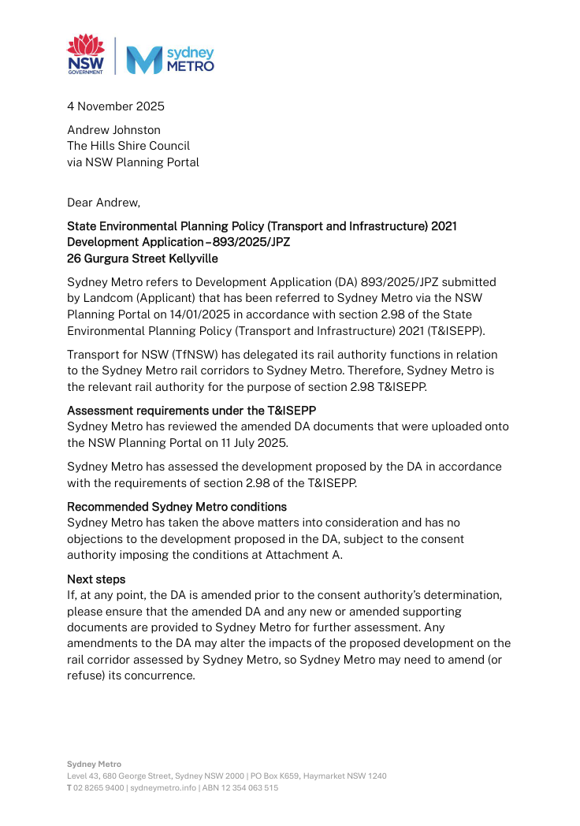
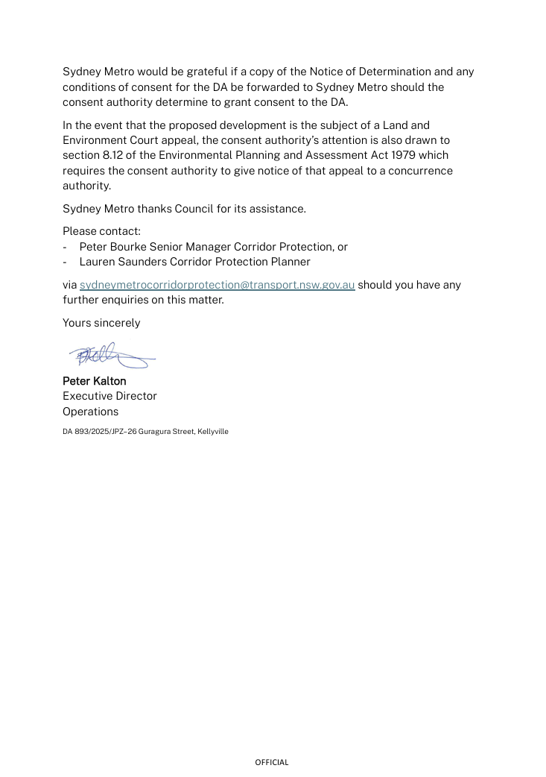

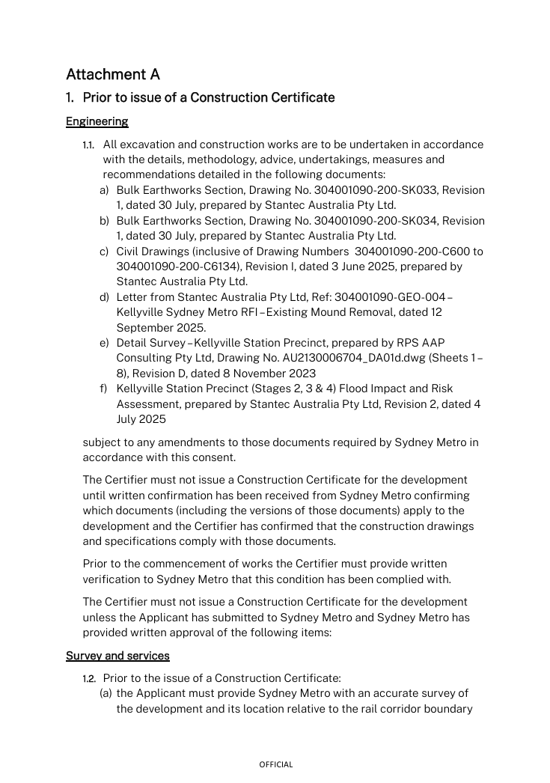

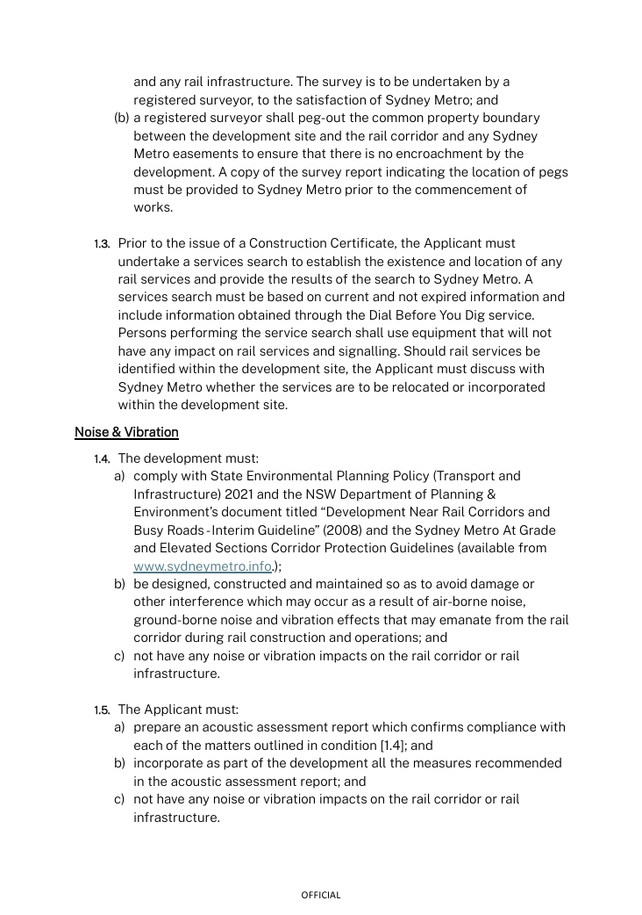

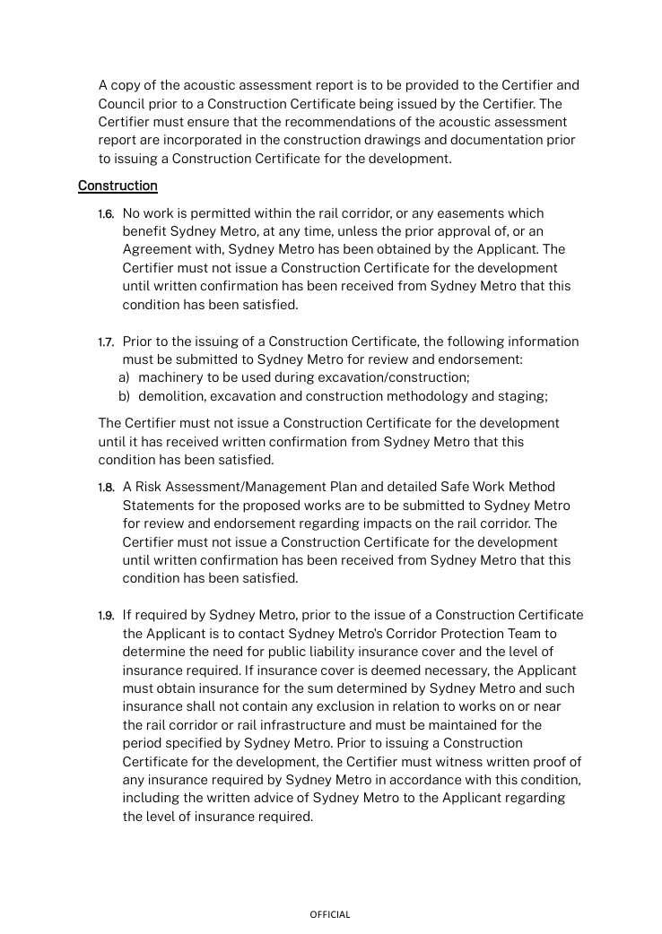

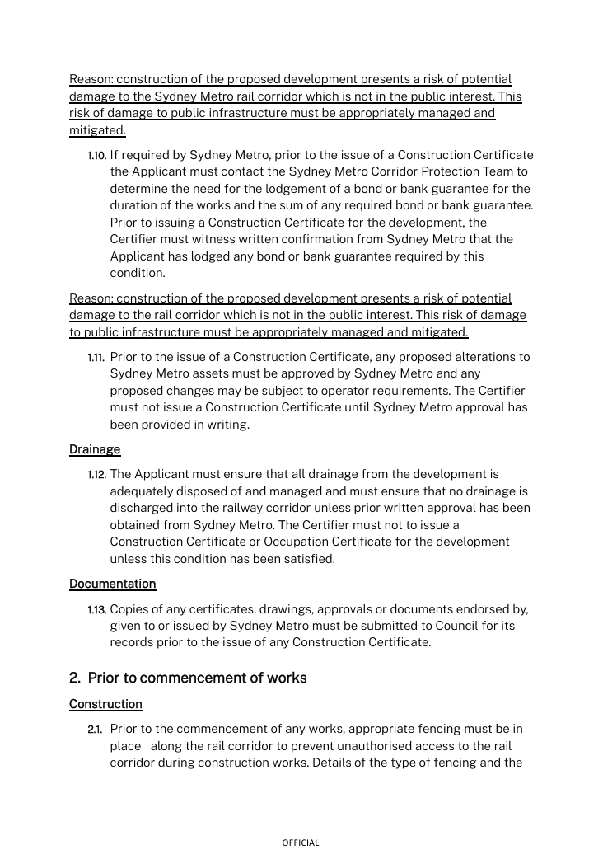

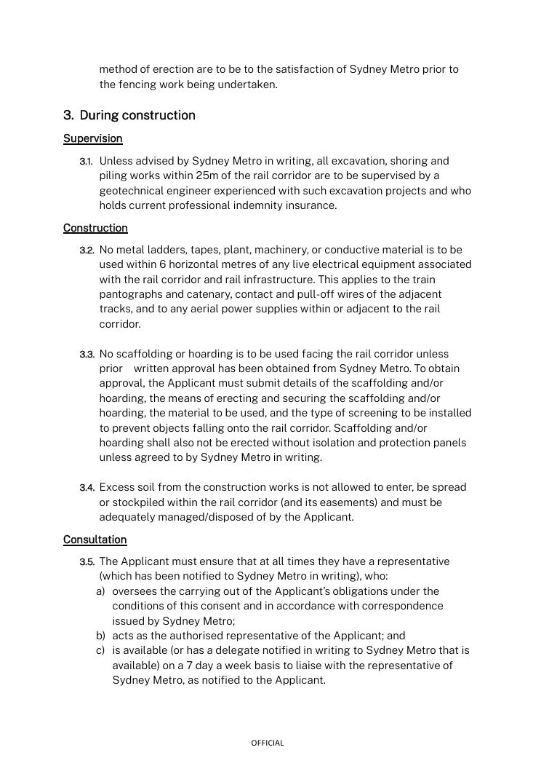

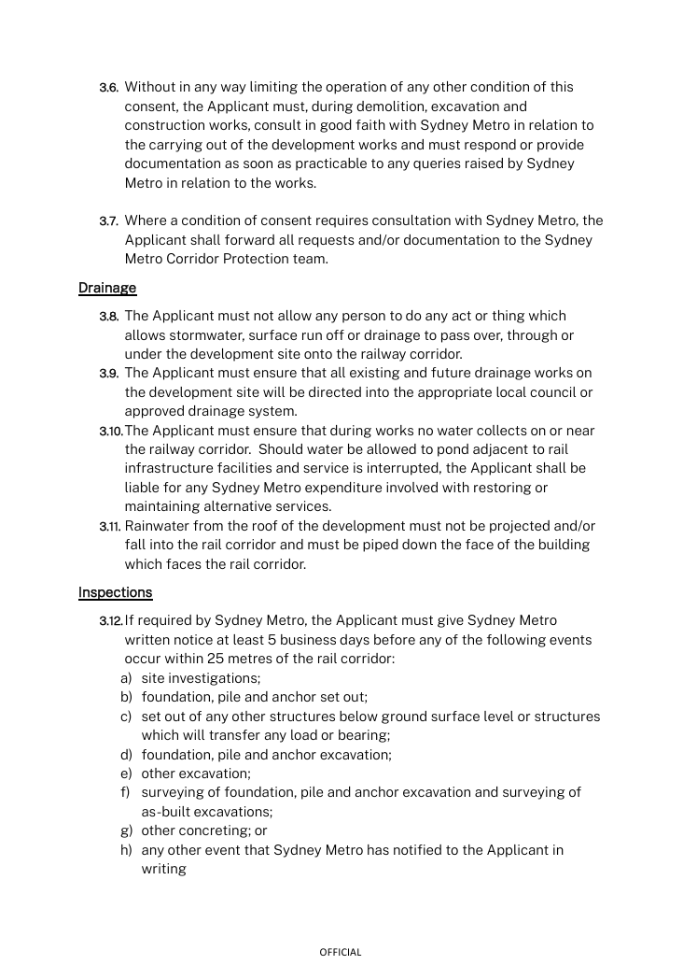

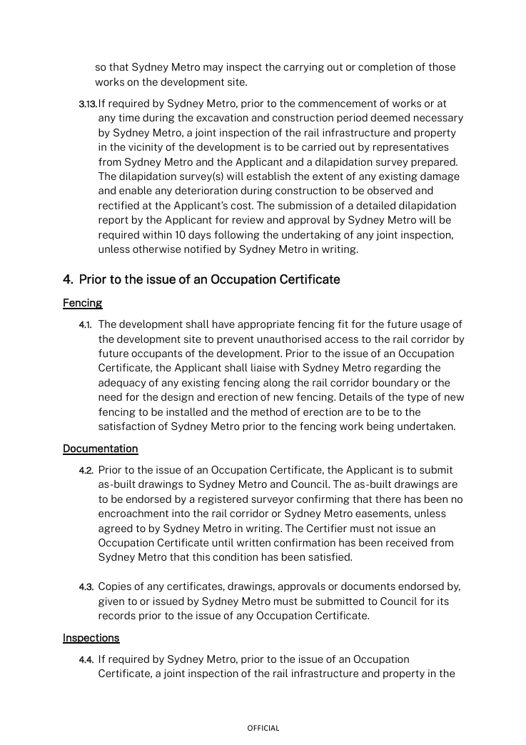

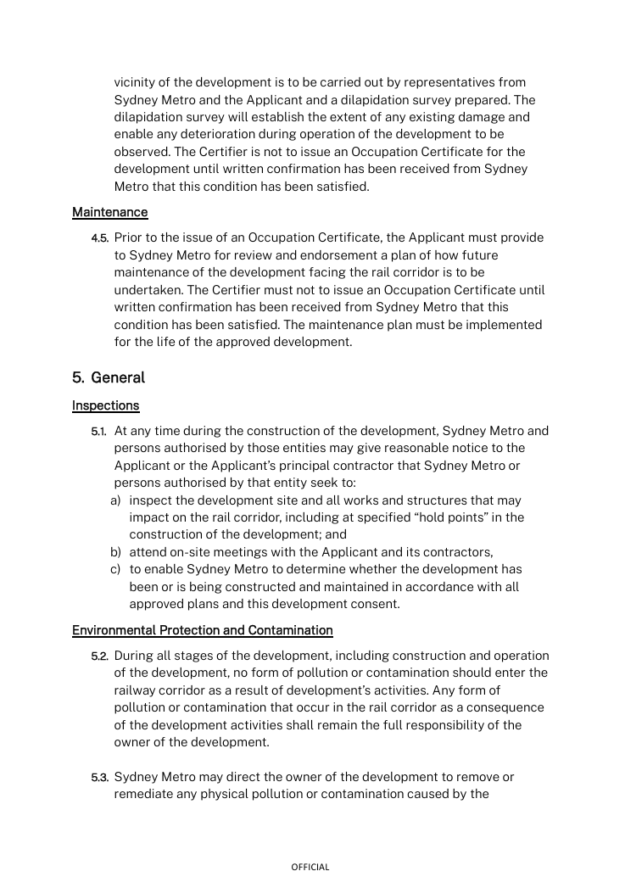

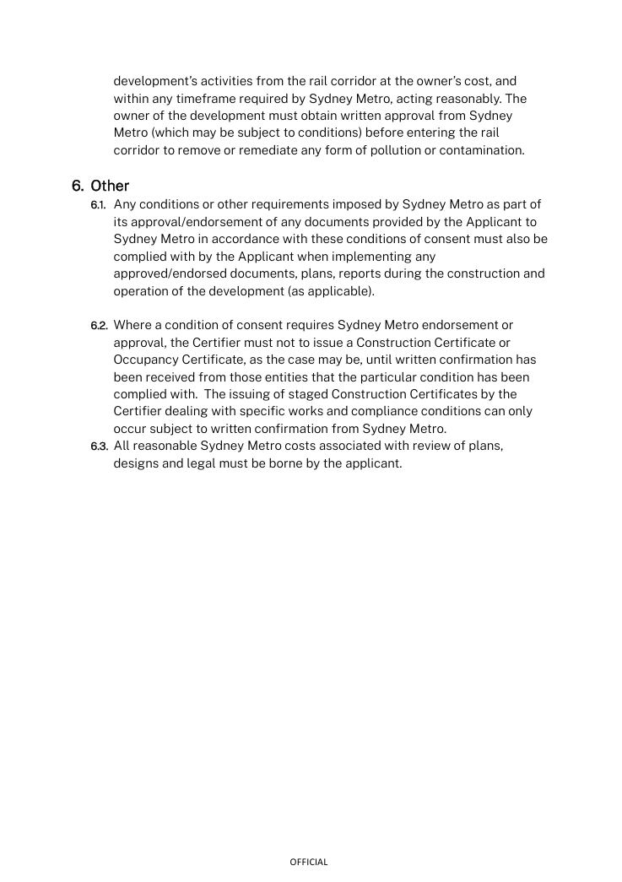
Appendix B – Sydney Water Requirements
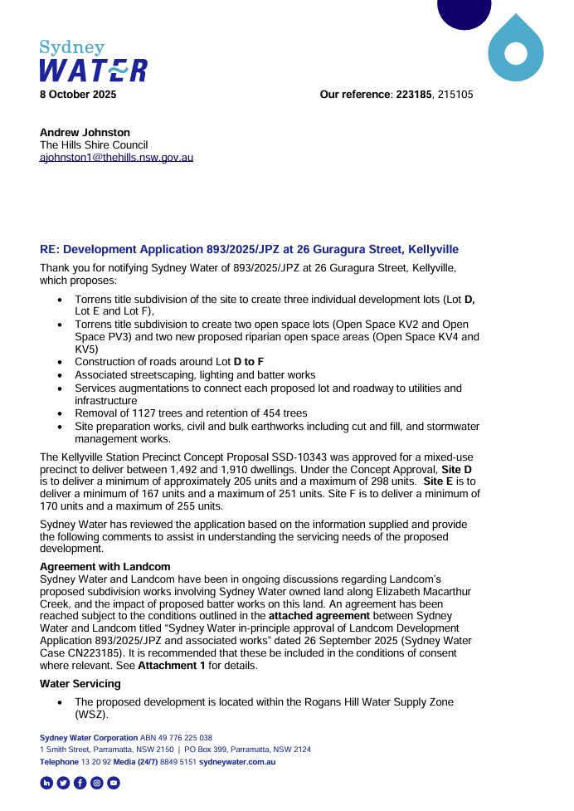

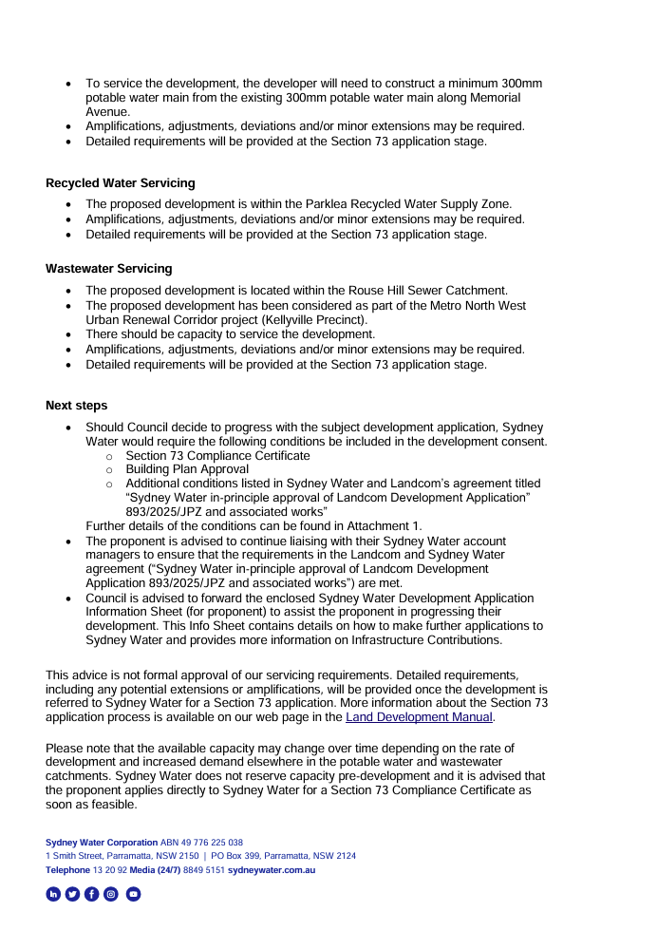

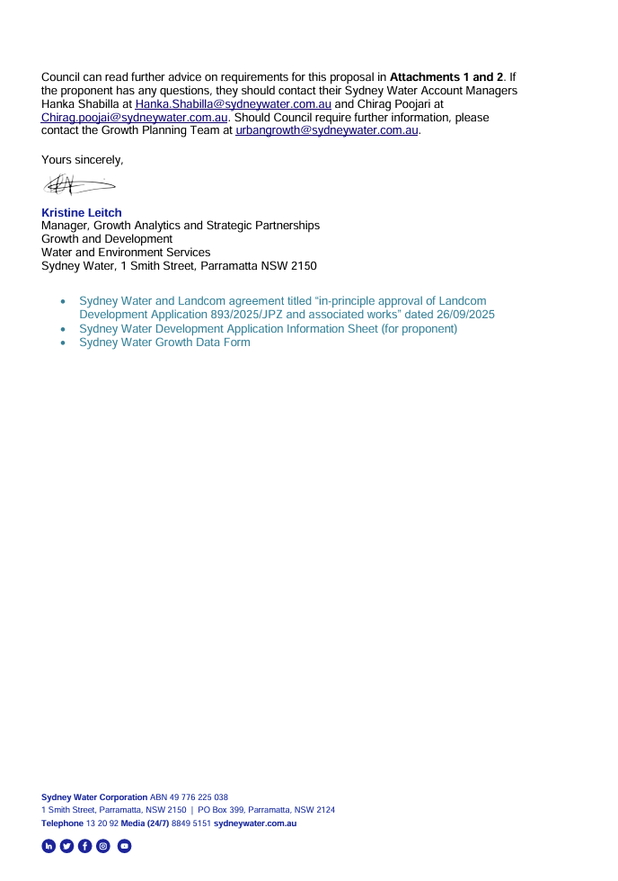

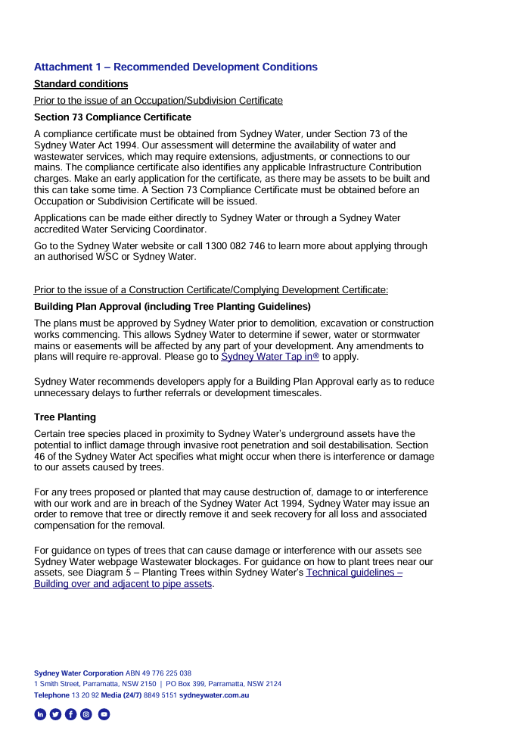

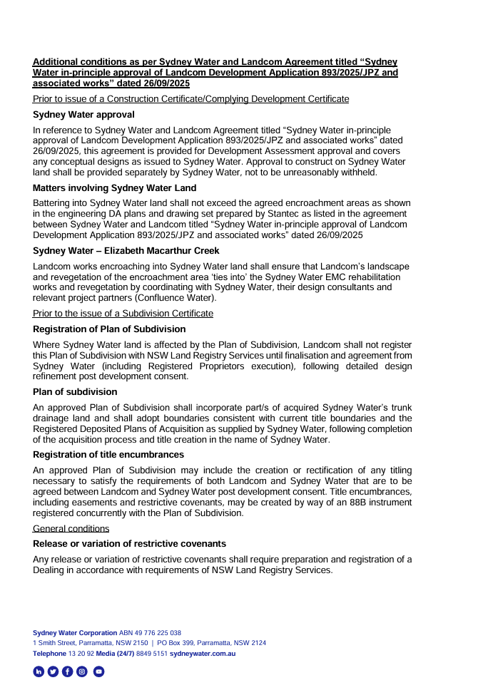

Appendix C – Transport For NSW Requirements
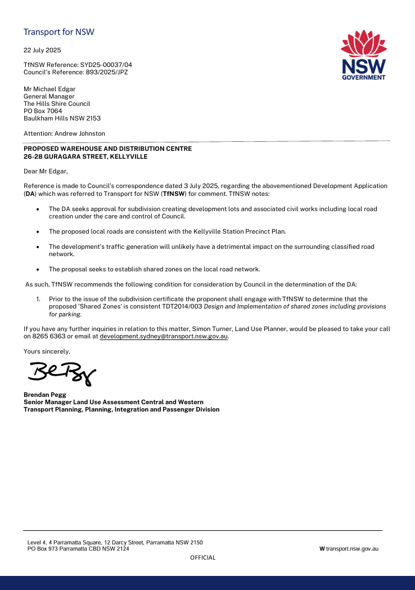

Dictionary
The following terms have the following meanings for the purpose of this determination (except where the context clearly indicates otherwise):
Approved plans and documents means the plans and documents endorsed by the consent authority, a copy of which is included in this notice of determination.
AS means Australian Standard published by Standards Australia International Limited and means the current standard which applies at the time the consent is issued.
Building work means any physical activity involved in the erection of a building.
Certifier means a council or a person that is registered to carry out certification work under the Building and Development Certifiers Act 2018.
Construction certificate means a certificate to the effect that building work completed in accordance with specified plans and specifications or standards will comply with the requirements of the EP&A Regulation and Environmental Planning and Assessment (Development Certification and Fire Safety) Regulation 2021.
Council means The Hills Shire Council.
Court means the Land and Environment Court of NSW.
EPA means the NSW Environment Protection Authority.
EP&A Act means the Environmental Planning and Assessment Act 1979.
EP&A Regulation means the Environmental Planning and Assessment Regulation 2021.
Independent Planning Commission means Independent Planning Commission of New South Wales constituted by section 2.7 of the EP&A Act.
Local planning panel means The Hills Local Planning Panel.
Occupation certificate means a certificate that authorises the occupation and use of a new building or a change of building use for an existing building in accordance with this consent.
Principal certifier means the certifier appointed as the principal certifier for building work or subdivision work under section 6.6(1) or 6.12(1) of the EP&A Act respectively.
Site work means any work that is physically carried out on the land to which the development the subject of this development consent is to be carried out, including but not limited to building work, subdivision work, demolition work, clearing of vegetation or remediation work.
Stormwater drainage system means all works and facilities relating to:
the collection of stormwater,
the reuse of stormwater,
the detention of stormwater,
the controlled release of stormwater, and
connections to easements and public stormwater systems.
Strata certificate means a certificate in the approved form issued under Part 4 of the Strata Schemes Development Act 2015 that authorises the registration of a strata plan, strata plan of subdivision or notice of conversion.
Subdivision certificate means a certificate that authorises the registration of a plan of subdivision under Part 23 of the Conveyancing Act 1919.
Subdivision works certificate means a certificate to the effect that subdivision work completed in accordance with specified plans and specifications will comply with the requirements of the EP&A Regulation.
Sydney district or regional planning panel means Sydney Central City Planning Panel.

